241CHEM
H.W 1 ( Chapter 1)
Question 1: answer the following:
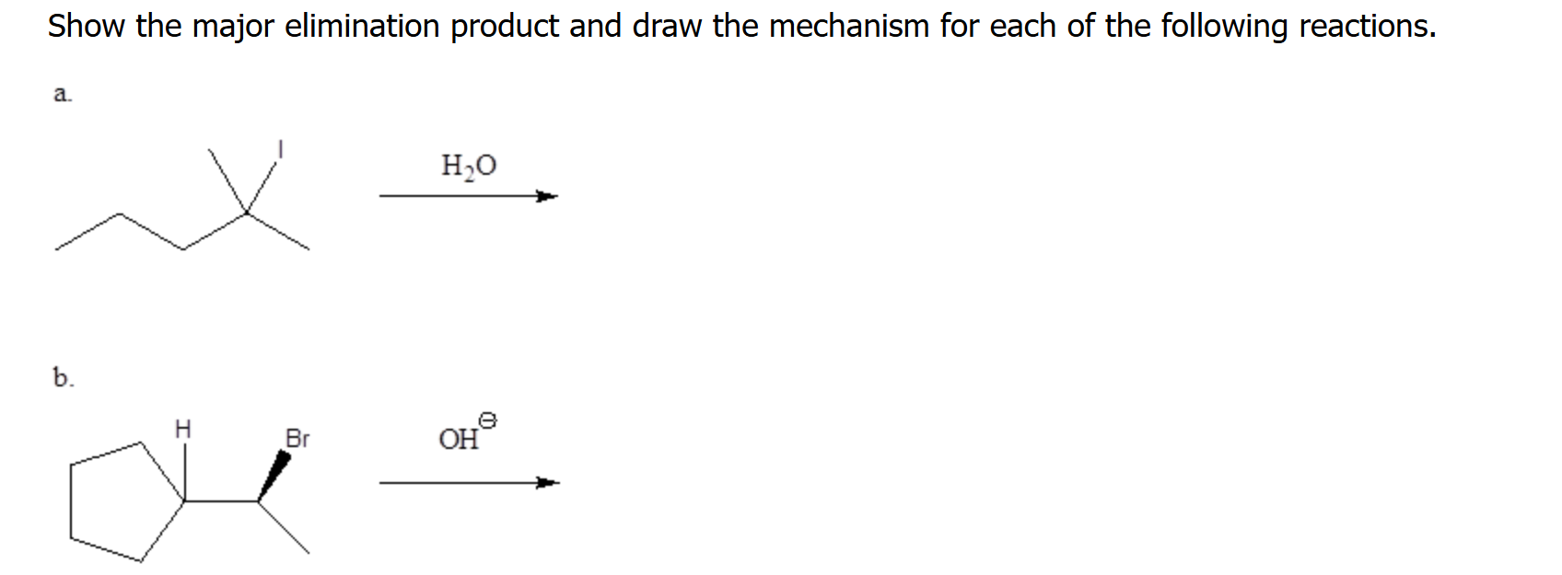

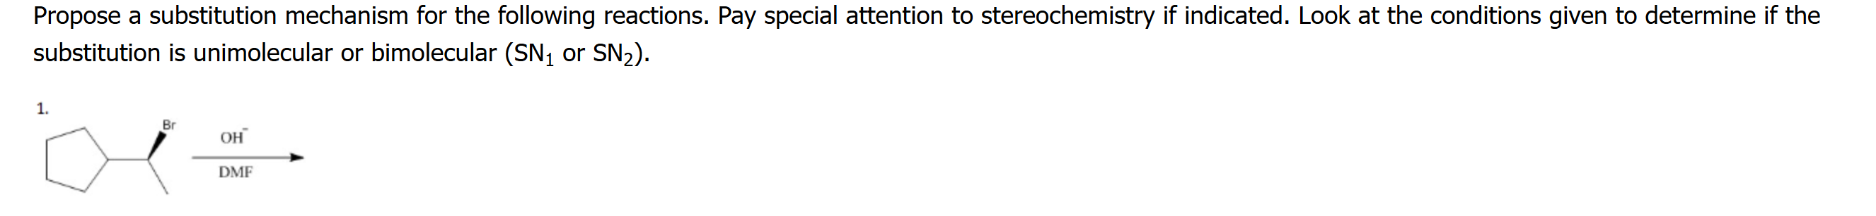

Question 2: Choose the correct answer:

1- Which statement below about Sn1 reactions is incorrect?

(A) Sn1 reactions are stepwise and have intermediates.
(B) The slow step in a Sn1 reaction is formation of the carbocation intermediate.
(C) Sn1 reactions have first order kinetics which means only the alkyl halide is involved in the rate limiting step.
(D) The products of a Sn1 reaction will be a pair of enantiomers.
(E) An aprotic solvent is best for Sn1 reactions as they tend to help stabilize carbocation intermediates.

2-What term refers to a process that occurs all at once and not stepwise?

(A) Concerted (B) Inversion (C) Retention (D) Unimolecular (E) Bimolecular

3- Which statement below regarding the physical properties of alkyl halides is false?
(A) Alkyl halides do not have intermolecular hydrogen bonding.
(B) Alkyl halides do have dipole-dipole attractions.
(C) As the size of the halogen increases, the boiling point of the alkyl halide increases.
(D) Alkyl fluorides and most alkyl chlorides are denser than water.
(E) Alkyl bromides and iodides are more dense than water

4- What is the product of the reaction of an alkyne with an excess of X2?
(A) A haloalkene
(B) A dihaloalkene
(C) A dihaloalkane
(D) A tetrahaloalkene
(E) A tetrahaloalkane

5-

