Saudi, Russian energy ministers sign ‘roadmap’ for cooperation

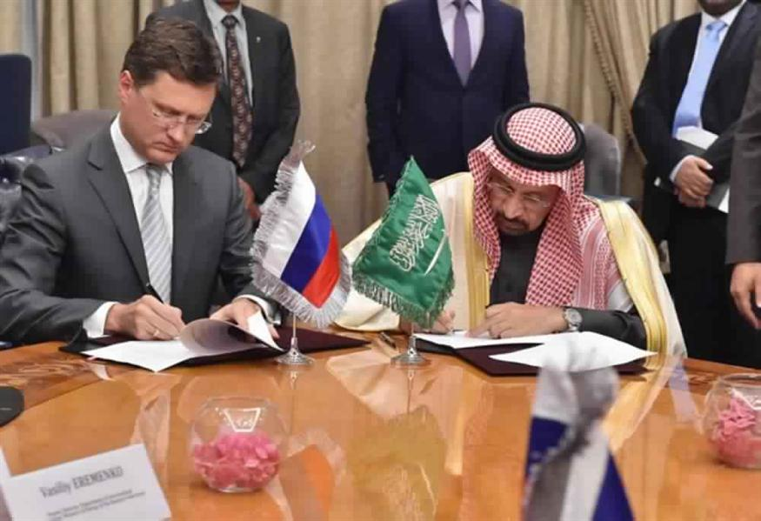

Saudi Arabia’s energy minister has signed a joint roadmap for cooperation with his Russian counterpart, as part of King Salman’s visit to Moscow, according to the official Saudi Press Agency (SPA).
The two ministers agreed to expand their oil and gas cooperation to cover renewable energy sources.

Our opinion about news is
Renewable energy will make a big different in Saudi Arabia. In present time, Saudi Arabia use the oil to generate the electricity. Therefore, using renewable energy to generate the electricity will reduce using the oil, and will raise the quantity of oil. In addition, it will open thousands of new jobs, and that will increase the percentage of employments. Moreover, this will contribute in increasing the general and individual economy.

Kholoud Bawazir 434203815
Mariam Alotaibi 434200890
Haifa aldawood 434200684

