Chapter- 2
Demand Analysis
Basics:
- In a market mechanism, the demand and supply curves interact to determine the price and quantity of a good or services.
- The analysis of demand and supply is essential to understand price and output movement in a market.
- Demand is the behaviour of potential buyers in a market.
- Demand is defined as the entire relationship between price and quantity.
- Quantity demanded of a commodity is defined as the quantity of that commodity demanded at a certain price during any particular period of time.
Features of Demand:
- It depends on the utility of the commodity;
- It always means effective demand. Always backed by purchasing power and willingness or ability to spend it;
- It is a flow concept;
- It refers to demand for final consumer goods;
- It is always related to certain price;
- It is a desired quantity. It shows consumers wish or need to buy the commodity;
- It does not refer to quantity actually bought.
Factors Affecting/ Determining Demand:
Main factors: | Other factors:
- Own price;  - Prices of other goods;  - Consumers’ income;  - Weather conditions  - Consumers’ tastes and preferences | - Income distribution;  - Past levels of demand and income;  - Population growth;  - Government policy;  - Wealth of the consumers.

Demand Function:
Functional relationship between demand for a commodity and its determinants is known as demand function.
Dx = f(Px, Py, Y, T);
Where; Dx = Demand for commodity x;
Px = Price of commodity x;
Py = Price of other commodity y;
Y = Consumers’ incomes
T = Consumers’ tastes and preference.
Law of Demand:
The relationship between quantity of a good that consumers are willing to buy and the price of the good that shows opposite relationship between price and quantity demanded is known as law of demand. In other words, higher the price, lower the demand and lower the price, higher the demand. That is, the quantity demanded is negatively related to the price of the good.
Dx = f (Px)
Where, Dx = Demand of commodity, x
Px = Price of commodity, x
f = functional relationship
Example: Demand Schedule for Sugar
Price (SR/Kg) | Quantity Demanded (Kg/month) | Reference points
1 | 10 | A
2 | 8 | B
3 | 6 | C
4 | 4 | D
5 | 2 | E

The demand curve slopes downwards to the right (or negatively sloped) indicating that the quantity demanded is inversely related to the price of the good.
Reasons behind downward slope of demand curve
Or, why demand curve slopes downwards to the right?
- Law of diminishing marginal utility;
- Substitution effect
- Income effect
- New consumers

Exceptions to the law of demand:
- Giffen goods;
- Veblen good;
- Exception of a price rise in future;
- Bandwagon effect;
- Emergency;
- Good with uncertain product quality;
- Snob appeal;
- Brand loyalty.
Individual Demand and Market Demand:
An individual demand curve is the demand for a good on the part of an individual consumer.
Market demand is the demand for a good on the part of all the consumers taken together.
Example: Individual Demands and Market Demand for Sugar
Price (SR/Kg) | Quantity Demanded by Individual “A” | Quantity Demanded by Individual “B” | Quantity Demanded by “A+B” (Market Demand)
1 | 5 | 4 | 5+4=9
2 | 4 | 3 | 4+3=7
3 | 3 | 2 | 3+2=5
4 | 2 | 1 | 2+1=3
5 | 1 | 0 | 1+0=1
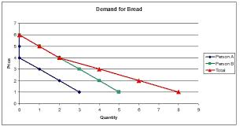
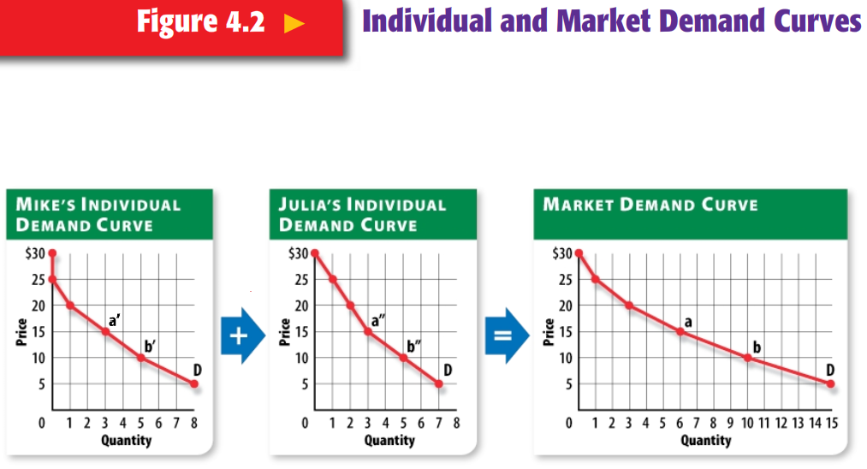
Complementary goods:
Two goods are said to be complements if an increase in the price of one good leads to a fall in the quantity demanded of other.
Example: Car and Petrol
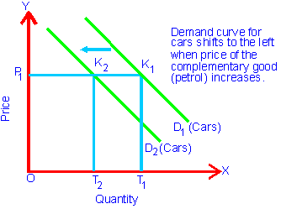 | 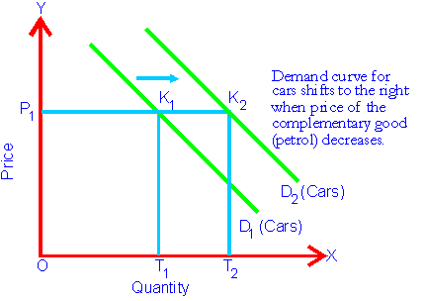

Substitute goods:
Two goods are said to be substitute if an increase in the price of one leads to an increase in the quantity demanded of the other.
Example: Tea and Coffee
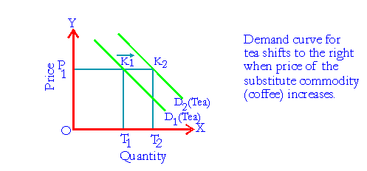 | 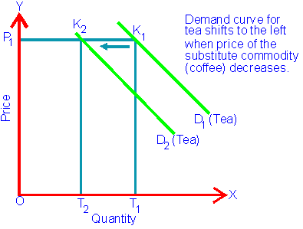

Demand and Income of the Consumer:
Dx = f (Y), ceteris paribus
How a change in the income will affect the demand for a good depends upon the type of the good:
- Normal good => Y↑↓ => Dx ↑↓ (Direct relationship between income and quantity demanded)
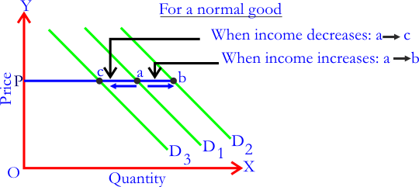

- Inferior good => Y↑↓ => Dx ↓↑ (Inverse relationship between income and quantity demanded)
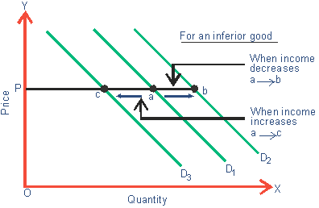
Demand and Consumer Tastes:
Dx = f (T), ceteris paribus

Change in Quantity Demanded (Movement) Vs Change in Demand (Shift) of Demand Curve:
Change in Quantity Demanded (Movement: Expansion or Contraction):
- A movement along the demand curve is caused by a change in the price of the good only, other things remaining the same.
- It is also called change in quantity demanded of the commodity.
- Movement is always along the same demand curve, i.e., no new demand curve is drawn.
- Movement along a demand curve can be of two types:
Expansion or extension of demand curve; and
Contraction of demand curve
- Expansion or extension of demand refers to rise in demand due to fall in the price of the good.
- Contraction of demand refers to fall in demand due to rise in the price of the good.
Change in Demand (Shift: Increase or Decrease in Demand Curve):
- A shift of the demand curve is caused by changes in factors other than price of the good. These other factors are:
- Consumer’s income;
- Price of other goods;
- Consumers’ tastes and preferences, etc
- A change in any of these factors causes shift of the demand curve. It is also called change in demand curve.
- Shift in demand curve means a new demand curve is drawn.
- A shift of the demand curve (or change in demand curve) can be of two types:
Increase in demand; and
Decrease in demand.
- Increase in demand refers to more demand at a given price or same demand at a higher price. This is due to-
- Increase in the income of the consumers;
- Increase in the price of substitute goods;
- Fall in the price of complementary goods;
- Consumers taste becoming stronger in favour of the good.
- Decrease in demand refers to less demand at the given price or same demand at a lesser price. This is due to-
- Fall in the income of the consumers;
- Fall in the price of substitute goods;
- Rise in the price of complementary goods;
- Consumers’ taste becoming unfavourable towards the goods.

REVIEW QUESTIONS
I. Objective Type/Multiple Choice Questions:
- Which is/are the determinants of demand-
- Price b. Income c. Taste and preference d. All of these.
- Price of the good is fixed in a market by-
- Demand, b. Supply, c. Both, d. None of these.
- The reasons for the downward slope of demand curve are-
- The law of diminishing marginal utility
- Substitution effect;
- Income effect;
- All of the above.
- In case of change in demand-
- No new demand curve is drawn;
- New demand curve is drawn;
- Both can be possible;
- None of these possible.
- If an increase in the price of one leads to an increase in the quantity demanded of the other then these goods are-
- Substitute goods; b. Complementary goods;
- c. Normal goods; d. None.
- Demand curve slopes upward in case of-
- Veblen goods; b. Giffen goods
- Snob appeal; d. all of the above.
- Which one is not the reason for change in demand -
- Price of the good;
- Price of other goods;
- Income of the consumer;
- Consumers’ taste and preferences
- Which one is not correctly matched-
- Giffen goods……………………a superior or high quality goods.
- Substitute goods………………..tea and coffee.
- Complementary goods………….car and petrol.
- Veblen goods………….a prestigious goods with status symbol.
Ques: | 1 | 2 | 3 | 4 | 5 | 6 | 7 | 8
Ans: | d | c | d | b | a | d | a | a
II. Write T for True and F False against the following questions:
- In case of Giffen goods and Veblen goods, law of demand does not work.
- In case of change in quantity demanded, new demand curve is drawn.
- If an increase in the price of one good leads to a fall in the quantity demanded of other then these goods are complementary goods.
- In case of normal goods, as income increases, demand for these goods also increases.
- Law of demand states that higher the price, lower the demand and lower the price higher the demand, other things remaining the same.
Ques: | 1 | 2 | 3 | 4 | 5
Ans: | T | F | T | T | T

III. Matching Test:
Match- I | Match- II
A. Change in demand will take place | a. On the same demand curve
B. Change in quantity demanded will take place | b. On new demand curve
C. Increase in demand | c. Rightward shift in demand curve
D. Decrease in demand | d. Leftward shift in demand curve

Match- I | A | B | C | D
Match- II | b | a | c | d

Match- I | Match- II
A. Demand curve slopes | a. Decrease in price of the good only
B. In case of Giffen goods, demand curve slopes | b. Decrease in other than the price of good
C. Expansion of demand curve is due to | c. Upward to the right.
D. Increase in demand curve is due to | d. Downward to the right.

Match- I | A | B | C | D
Match- II | d | c | a | b

IV. Questions with Answer
Ques: What is demand?
Ans: Demand is defined as the entire relationship between price and quantity. Quantity demanded of a commodity is defined as the quantity of that commodity demanded at a certain price during any particular period of time.
Ques: What are the factors affecting individual demand?
Ans: Followings are the factors that affect individual demand:
Main factors: | Other factors:
- Own price;  - Prices of other goods;  - Consumers’ income;  - Weather conditions  - Consumers’ tastes and preferences | - Income distribution;  - Past levels of demand and income;  - Population growth;  - Government policy;  - Wealth of the consumers.

Ques: What is law of demand? Explain it with suitable example.
Ans: The relationship between quantity of a good that consumers are willing to buy and the price of the good that shows opposite relationship between price and quantity demanded is known as law of demand. In other words, higher the price, lower the demand and lower the price, higher the demand. That is, the quantity demanded is negatively related to the price of the good.
Dx = f (Px) = a - bPx
Where, Dx = Demand of commodity, x
Px = Price of commodity, x
a = Intercept of Demand curve
b = Slope of demand curve
f = functional relationship

Example: Demand Schedule for Sugar
Price (SR/Kg) | Quantity Demanded (Kg/month) | Reference points
1 | 10 | A
2 | 8 | B
3 | 6 | C
4 | 4 | D
5 | 2 | E

The demand curve slopes downwards to the right (or negatively sloped) indicating that the quantity demanded is inversely related to the price of the good.
Ques: What are substitute goods?
Ans: Two goods are said to be substitute if an increase in the price of one leads to an increase in the quantity demanded of the other.
Example: Tea and Coffee

Ques: What are complementary goods?
Ans: Two goods are said to be complements if an increase in the price of one good leads to a fall in the quantity demanded of other.
Example: Car and Petrol
Ques: What are normal and inferior goods?
Ans: Normal Good: That good when income increases, quantity demanded also increases is called normal good.
Inferior Good: That good when income increases, quantity demanded decreases is called inferior good.

Ques: What are the reasons behind the downward slope of demand curve?
Ans: The reasons for downward sloping demand curve are:
- Law of diminishing marginal utility;
- Substitution effect
- Income effect
- New consumers
Ques: What are the exceptions to the law of demand curve?
Ans: The exceptions to the law of demand curve are:
- Giffen goods;
- Veblen good;
- Exception of a price rise in future;
- Bandwagon effect;
- Emergency;
- Good with uncertain product quality;
- Snob appeal;
- Brand loyalty.
Ques: What are the differences between expansion in demand and increase in demand curve?
Ans:
Expansion in demand | Increase in demand
1. Expansion or extension of demand refers to rise in demand due to fall in the price of the good. | 1. Increase in demand refers to more demand at a given price or same demand at a higher price.
2. This occurs on the same demand curve. | 2. It occurs on the new demand curve.
3. The reason of extension or expansion in demand is decrease in price of the good only. | 3. The reasons for increase in demand are other than the price of good.

Ques: What happens when quantity demanded is related to-
- Income of the consumers
- Tastes and preferences of the consumers.
Ans: a. Income of the consumers and Demand for goods:
Dx = f (Y), ceteris paribus
How a change in the income will affect the demand for a good depends upon the type of the good:
Normal good => Y↑↓ => Dx ↑↓ (Direct relationship between income and quantity demanded)
Inferior good => Y↑↓ => Dx ↓↑ (Inverse relationship between income and quantity demanded)
b. Tastes and preferences of the consumers and demand for good:
Taste and preference of the consumer also affect demand for goods.
Ques: What are Giffen goods?
Ans: Giffen goods are those inferior goods which do not follow law of demand. In other words, as price of that commodity decreases, quantity demanded of that commodity also decreases and vice versa. In case of Giffen goods, law of demand fails.
Ques: What is Snob and Bandwagon effect?
Ans: Bandwagon Effect: It refers to desire or demand for a good by a person who wants to be in style because possession of a good is in fashion and therefore many others have it. It is an example of positive network externality. Bandwagon effect makes the demand curve elastic.
Snob Effect: It refers to the desire to possess a unique commodity having a prestige value. It works quite contrary to the bandwagon effect. It is an example of negative network externality. Snob effect makes the demand curve less elastic (inelastic).

