**King Saud University**

**Faculty of science**

**Zoology Department**

**Practical Examination**

**Course Number (109 Zoo)**

**Second Semester (1445-2024)**

**Student's Name: __________**نموذج اختبار **_________ Student's Number________________**

**Q1/ Identify the spots from1 to 12: (**12 marks)

1. **Oxyntic cells in the Mucosa of the Stomach**…………………………………
2. ………………… **T.S of the spinal cord** …………………………………….
3. …………………… **Arm** ……………………………………….…………….
4. ………………………………………………………………………………….
5. ………………………………………………………………………………….
6. ………………………………………………………………………………….
7. ………………………………………………………………………………….
8. ………………………………………………………………………………….
9. ………………………………………………………………………………….
10. ……………… **Mitosis in animal cell (prophase)** ………………………….….
11. ………………………………………………………………………………….
12. ………………………………………………………………………………….

**Q2/ Write the *phenotype* and full *genotype* for the following pictures: (**2 marks)

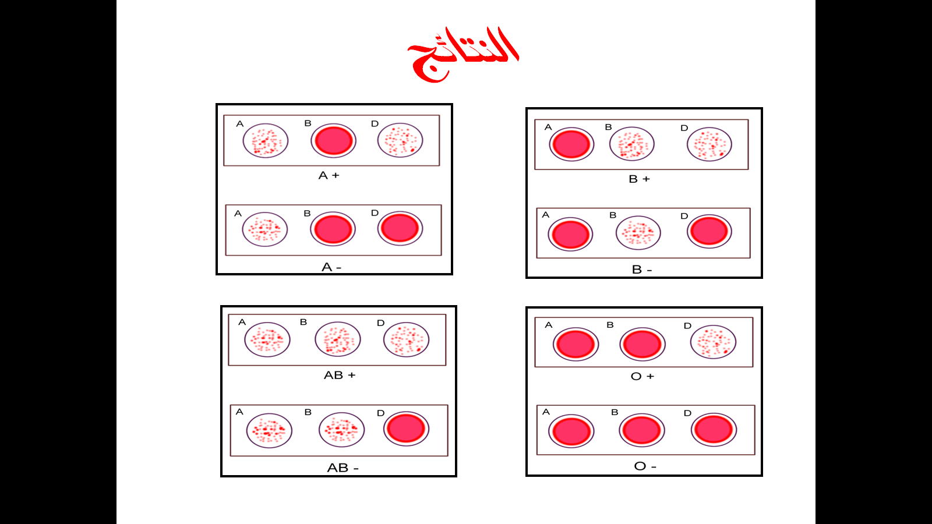

**Phenotype:** …………………O+…………………

**Genotype:** …………ii / DD,Dd ………………...

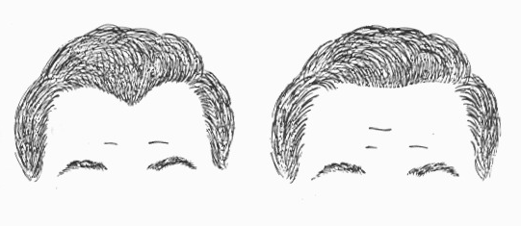

**Phenotype:** …………………………………………. (0.5 mark)

**Genotype:** …………………….……………………… (1 mark)

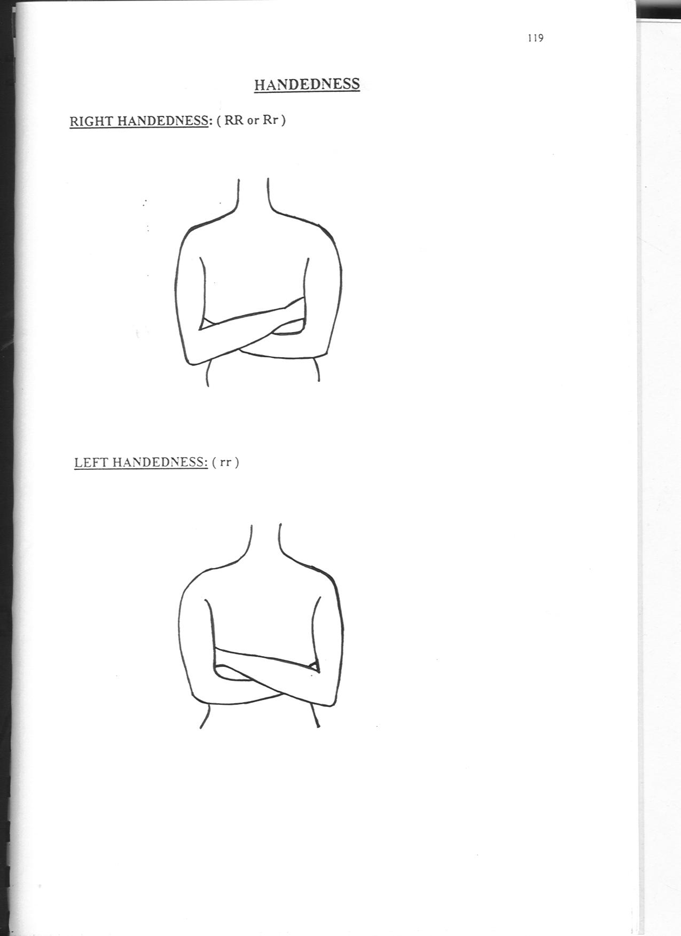

**Phenotype:** …………………………………………. (0.5 mark)

**Genotype:** ………………………….………………. (1 mark)

**Q3/ Draw and write the name of the parts of the following spot.** (3 marks)

**Name of the slide:** ............... **T.S of the Vein** .............................

