**Microbial physiology (MBIO 331) Practical Part**

Cource Number: 331 MBIO

Course Name: **Microbial physiology**

**Experiment Number: Lab Safety**

**Top 10 laboratory safety rules:-**

1. Follow the instructions

Whether it’s listening to your instructor or lab supervisor or following a procedure in a book, it’s critical to listen, pay attention, and be familiar with all the steps, from start to finish, before you begin. If you are unclear about any point or have questions, get them answered before starting, even if it’s a question about a step later on in the protocol. Know how to use all of the lab equipment before you begin.

2. Keep snacks out of the lab

Food and drinks should never be consumed in a lab. There is a chance that they could become contaminated by the chemicals used in the lab. There is also a chance that the food and drinks could spill and contaminate an experiment. If you need to eat or drink, make sure you do it before you enter a lab or wait until you leave.

3. Don’t sniff the chemicals

Not only should you not bring in food or drinks, but you shouldn’t taste or smell chemicals or biological cultures already in the lab. Tasting or smelling some chemicals can be dangerous or even deadly. The best way to know what’s in a container is to label it, so get in the habit of making a label for glassware before adding the chemical.

4. Dispose of waste properly

Much of the waste created in a lab needs to be disposed of in something other than just the regular waste bin. You also need to avoid dumping most chemicals down a drain since it could be bad for the plumbing system and potentially the environment. Make sure you know how to dispose of everything you plan on using in the lab before you start your next experiment.

5. Identify safety equipment

If something goes wrong while you’re in the lab, you need to know where the safety equipment is located so that you can start using it right away. From the location of the fire extinguisher to the location of the eye wash, you should make sure the safety equipment is present and point out where it is before you begin an experiment.

6. Think safety first

If a chemical were to spill in the lab, what would you do? Or if you were injured while doing an experiment, what would be your next move? It’s impossible to eliminate all accidents from a lab, but you can take the right steps to prepare yourself for one. It could prevent a small problem from turning into a larger one.

7. Dress for the lab

From the moment you walk into a lab, you need to be dressed properly from head to toe. This means wearing long pants, a lab coat, safety goggles, covered shoes, and any other protective gear required by the lab. You should also put your hair up if you have long hair and wear gloves and hearing protection if the experiment you are conducting calls for them.

8. Don’t play the mad scientist

Another important safety rule is to act responsibly in the lab. Don’t play Mad Scientist, randomly mixing chemicals to see what happens. The result could be an explosion, fire, or release of toxic gases. Similarly, the laboratory is not the place for horseplay.

9. Leave Experiments at the Lab

It’s important, for your safety and the safety of others, to leave your experiment in the lab. Don’t take it home with you. You could have a spill or lose a specimen or have an accident. This is how science fiction films start. In real life, you can hurt someone, cause a fire, or lose your job.

10. Don’t experiment on yourself

The plot of many science fiction films starts with a scientist conducting an experiment on him or herself. However, you won’t gain superpowers or discover the secret to eternal youth. More than likely, whatever you accomplish will be at great personal risk.

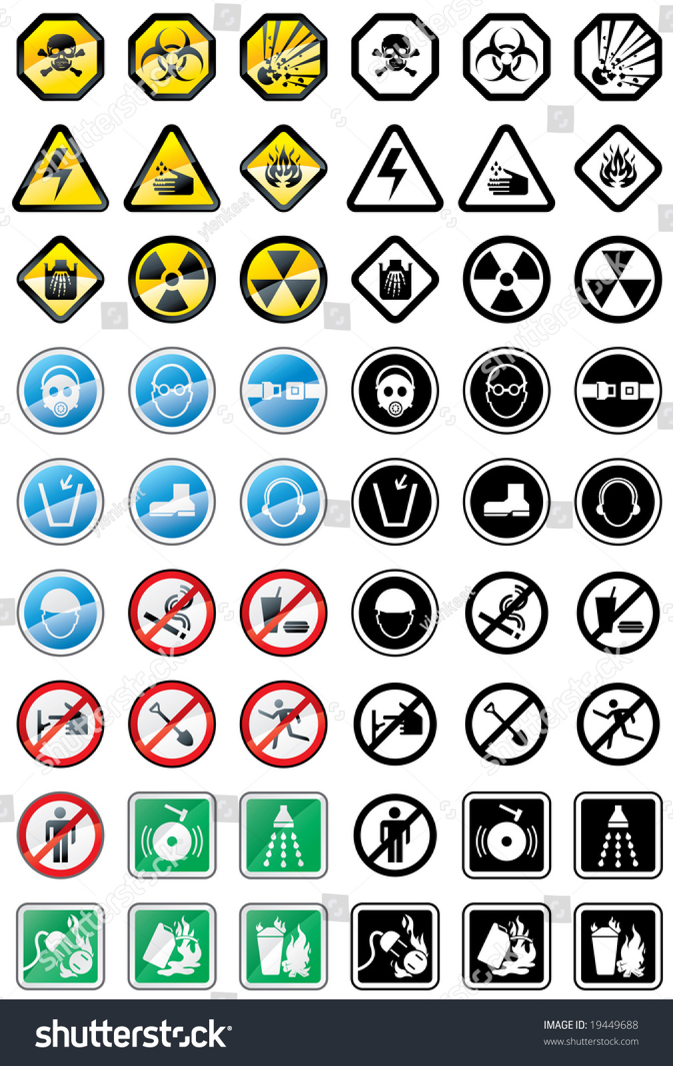

Course Number: 331 MBIO

Course Name: **Microbial physiology**

**Experiment Number: 1st**

**Introduction**

Giving a brief introduction to the microbial physiology practical course along with the syllabus content and objectives.

**Course Number: 331 MBIO**

**Course Name**: **Microbial physiology**

**Experiment Number: 2nd**

**Experiment title**

**Isolation and identification of microbes from soil samples**

**:Brief introduction**

The student will be able to distinguish between different patterns of growth to various bacterial and fungal species isolated.

**:Materials, tools and equipment used**

• soil

• plates

• Ethanol

• tubes

**Methods:**

Make a serial dilution from 1g of soil. Spread onto plates from each dilution. Thereafter, incubate at 28°C for one week. Evaluation of data on the next week.

**Results and observations:**

On a given medium, a colony’s shape, color, consistency, surface appearance and size - for a given incubation time - are often characteristic, and these are often of use in the identification of particular bacterial strains. The full description of a colony can be very detailed. Thus e.g. the elevation of a colony may be flat, low convex, domed unbonate etc., its edge maybe entire [circular or unbroken], crenate [scalloped], lobed or fimbriate; its texture may be butyrous friable or mucoid; its surface may be matt or glossy; it may be whitish or pigmented or it may contain a dye taken up from the medium, or it may release water soluble pigment into the medium. The colonies of certain bacteria e.g. *Bacillus* can migrate across the surface of a culture plate, the tract of such movement is often marked by lines of bacterial growth which arise from the cells left behind by the migration colony. An interesting feature of certain bacterial colonies is the so-called smooth-rough variation. In many types of bacteria, some type of S-R variation is responsible for a change in the cell-surface composition, which occurs spontaneously during in vitro or in vivo growth. S-R variation was first recorded in enterobacteria, in which smooth [glossy] colony may be formed on primary isolation, and rough [dull] colonies may develop on subcultures.

**Expected results**



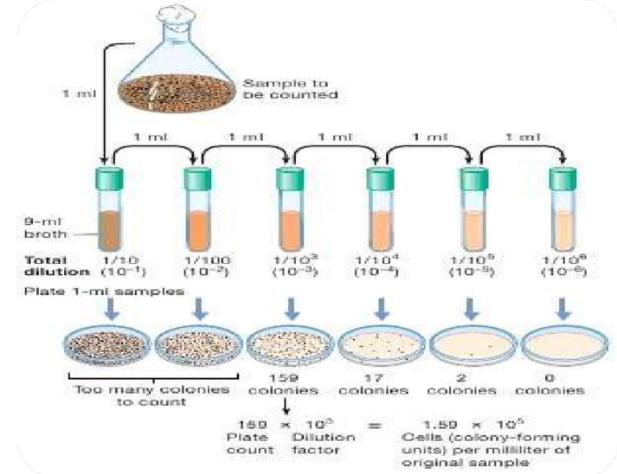

**Serial dilution Method**

**The Reviewer**

1. Practical Microbial physiology Prof. Nawal Mohammed Atba Prof. Hal Younis Fadel.

Course number and code: 331 MBIO

Course Name: **Microbial physiology**

**Experiment Number: 3ed**

Experiment title:

**Metabolism**

In this lesson, you will learn how to prepare a leaf skin excision from several plants from several plant families belonging to monocotyledonous and dicotyledonous plants, in order to learn about the types of stomata, their shapes, and how they differ from one plant to another, as well as to learn about the types of epidermal cells, dermal hairs, and others.

**Methods:**



 







**Course Number: 331 MBIO**

**Course Name**: **Microbial physiology**

**Experiment Number: 4th**

**Experiment title**

**Test chemical factors affecting microbial growth (1- Carbon source)**

**:Brief introduction**

The student will be able to differentiate between different patterns of growth due to the effect of carbon source.

**:Materials, tools and equipment used**

• Glucose

• Fructose

• Arabinose

• Ethanol

• tubes

**Methods:**

Pipette 0.5 ml bacterial suspension aseptically into test tubes containing nutrient broth of different carbon sources (Glucose, Fructose and Arabinose). Followed by incubation at 28°C for a week.

**Results and observations:**

**Observe the turbidity of each broth and compare it with other tubes.**

**Expected results: Bacteria will grow better on Glucose as simplest source of carbon followed by Fructose, then Arabinose.**

**Course Number: 331 MBIO**

**Course Name**: **Microbial physiology**

**Experiment Number: 5th**

**Experiment title**

**Test chemical factors affecting microbial growth (1- Carbon source)**

**:Brief introduction**

The student will be able to differentiate between different patterns of growth due to the effect of carbon source.

**:Materials, tools and equipment used**

• Glucose

• Fructose

• Arabinose

• Ethanol

• tubes

**Methods:**

Pipette 0.5 ml bacterial suspension aseptically into test tubes containing nutrient broth of different carbon sources (Glucose, Fructose and Arabinose). Followed by incubation at 28°C for a week.

**Results and observations**

Observe the turbidity of each broth and compare it with other tubes.

**Expected results**

Bacteria will grow better on Glucose as simplest source of carbon followed by Fructose, then Arabinose.

**Course Number: 331 MBIO**

**Course Name**: **Microbial physiology**

**Experiment Number: 6th**

**Experiment title**

**Test chemical factors affecting microbial growth (2-Nitrogen source)**

**Brief introduction:**

The student will be able to differentiate between different patterns of growth due to the effect of Nitrogen source.

**Materials, tools and equipment used**

• Peptone

• Tryptone

• Yeast extract

• Ethanol

• tubes

**Methods:**

Pipette 0.5 ml bacterial suspension aseptically into test tubes containing nutrient broth of different Nitrogen sources (Peptone, Tryptone and Yeast extract). Followed by incubation at 28°C for a week.

**Results and observations**

Observe the turbidity of each broth and compare it with other tubes.

**Expected results**

Bacteria will grow better on Pyptone as simplest source of carbon followed by Tryptone, then Yeast extract.

**Course Number: 331 MBIO**

**Course Name**: **Microbial physiology**

**Experiment Number: 7th**

**Experiment title**

**Test physical factors affecting microbial growth (1-PH)**

**Brief introduction**

**The student will be able to differentiate between different patterns of growth due to the effect of PH.**

**Materials, tools and equipment used**

**• pH=3 solution**

**• pH=7 solution**

**• pH=9 solution**

**• Ethanol**

**• tubes**

**How it works**

Pipette 0.5 ml bacterial suspension aseptically into test tubes containing nutrient broth of different pH values (pH=3, pH=7, pH=9). Estimate the pH tolerance of each strain by examining the growth rate of the bacteria following incubation at 28°C for a week.

**Results and observations**

**Observe the turbidity of each broth and compare it with a blank test tube that has not been inoculated with bacteria.**

**Course Number: 331 MBIO**

**Course Name**: **Microbial physiology**

**Experiment Number: 8th**

**Experiment title**

**Test physical factors affecting microbial growth (2-Temperature)**

**Brief introduction**

The student will be able to differentiate between different patterns of growth due to the effect of Temperature.

**Materials, tools and equipment used**

• Ethanol

• tubes

• Nutrient Broth medium

• Shaker incubater

**How it works:**

Transfer the different strains of bacteria (from suspension or agar slants) onto fresh nutrient agar slants and incubate each strain at 4°C, 28°C and 50°C.

**Results and observations**

Observe the rate of bacterial growth on the medium after a week-long incubation.

**Expected results**

Bacteria will grow better on at 28°C followed by 50°C then 4°C.

**Course Number: 331 MBIO**

**Course Name**: **Microbial physiology**

**Experiment Number: 9th**

**Experiment title**

**Test chemical factors affecting microbial growth (3-NaCl)**

**Brief introduction**

The student will be able to differentiate between different patterns of growth due to the effect of different salt concentrations.

**Materials, tools and equipment used**

• Ethanol

• NaCl

• tubes

**Methods:**

Inoculate bacterial suspension into culture broth of different salt concentration values (0%, 5%, 10%). The germicidal effect should be evaluated following incubation at 28°C for a week.

**Results and observations**

Estimate the osmo-tolerance of each strain by examining the growth rate of the bacteria following incubation at 28°C for a week (observe the turbidity of each broth and compare it with a blank test tube that has not been inoculated with bacteria).

Course **Number: 331 MBIO**

**Course Name**: **Microbial physiology**

**Experiment Number: 10th**

**Experiment title**

**Test physical factors affecting microbial growth (4-Aerobic and Anaerobic conditions)**

**Brief introduction**

Aerobic means involving oxygen, so anaerobic bacteria can survive without oxygen.  
The oxygen requirements can be used to classify microorganisms into obligate aerobes, facultative anaerobes, obligate anaerobes, aerotolerant anaerobes.

The student will be able to differentiate between different patterns of growth due to the effect of oxygen availability.

***Staphylococc****i* and ***Enterobacteriaceae*** are examples of facultative anaerobes.

Examples of aerotolerant anaerobes include ***lactobacilli* and *streptococci***,***Campylobacter spp***, is an example of a microaerophile and is grown under low-oxygen conditions. ***Clostridium spp***  is an obligate anaerobe.

**Materials, tools and equipment used**

• Ethanol

• loop

• tubes

• Aerobic and anaerobic bacterial cultures

• Thioglycolate Medium

• Co2 Incubater

• Anaerobic Jar

**Methods:**

Inoculate bacterial suspension into nutrient broth (thioglycolate) and nutrient agar. Incubate the cultures under both aerobic and anaerobic conditions at 37°C for 24 h.

**Results and observations**

Estimate the bacterial strain tendency to grow under different conditions of oxygen availability by examining the growth rate of the bacteria following incubation at 37°C (observe the turbidity and growth of each tubes and plates compare it with a blank that has not been inoculated with bacteria).

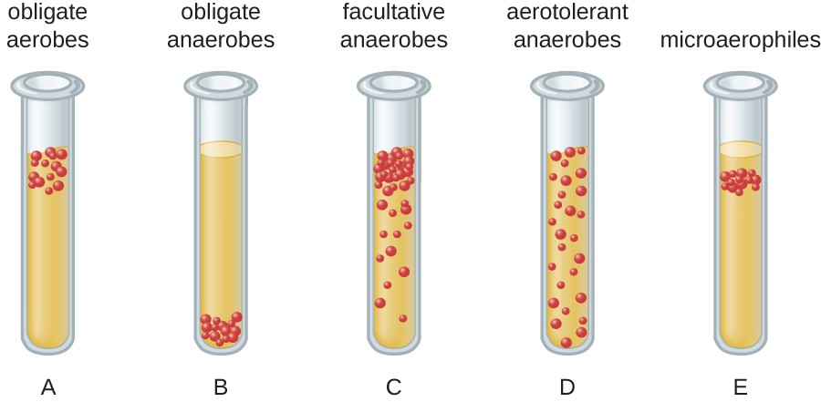

Diagram of bacterial cell distribution in thioglycolate tubes.

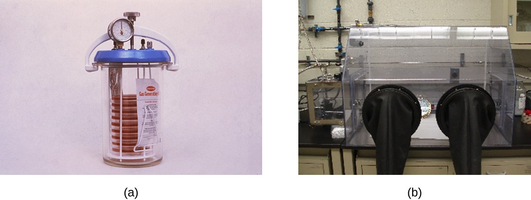

1. An anaerobic jar is pictured that is holding nine Petri plates supporting cultures. (b) Openings in the side of an anaerobic box are sealed by glove-like sleeves that allow for the handling of cultures inside the box.

**Course Number: 331 MBIO**

**Course Name**: **Microbial physiology**

**Experiment Number: 11th**

**Experiment title**

**Testing antibiotics against bacterial cultures**

**Brief introduction**

The student will be able to differentiate between different patterns of growth due to the antibiotic resistance of some bacteria.

**Materials, tools and equipment used**

• Ethanol

• loop

• Ethanol

• Plant extract

• tubes

**Methods:**

In this method a culture of known concentration is spreaded on an appropriate medium (Mueller-Hinton medium). Filter paper discs containing predetermined concentrations of an antimicrobial are placed on the seeded agar plate, with equal spacing between discs (Generally 4 discs / Petri dish). During incubation, the agent diffuses out of the disc, creating a concentration gradient that decreases according to distance away from the disc.

**Results and observations**

After the incubation the organisms, sensitivity is measured on the basis of the size of the zone of inhibition (no growth) around each disc. This measure is compared to values on a standard, and it indicates whether the microorganism is resistant, intermediate or sensitive to the agar. Sensitive means that the organism is inhibited by clinically attained concentrations of the antimicrobial; resistant means that the organisms is not inhibited; intermediate meant that special considerations are to be followed if the antibiotic is to be used.

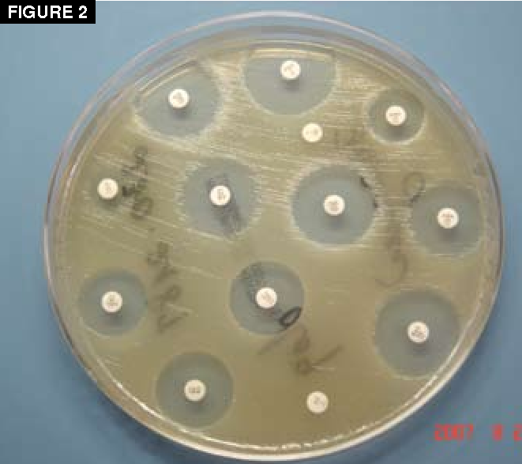

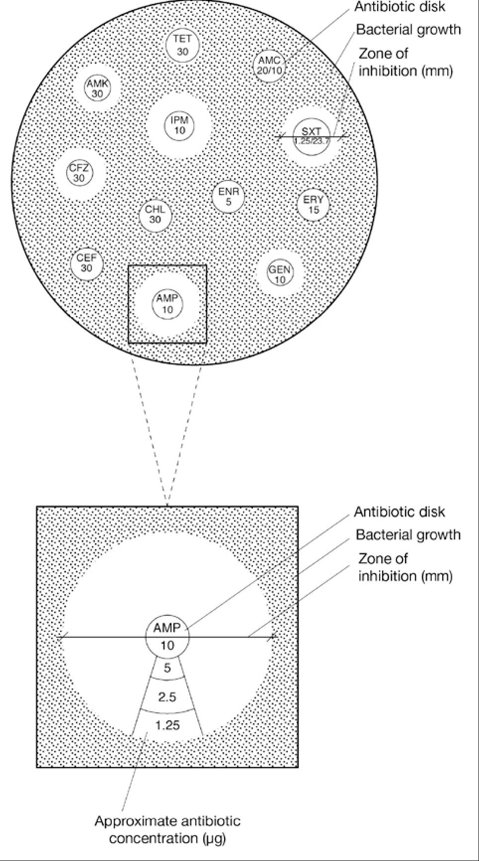

References :-

1. Bacterial culture and antibiotic susceptibility testing.Stephanie A. Pierce-Hendry, Jeffrey Dennis Published in Compendium 1 July 2010 Medicine.
2. Bookshelves/Microbiology/Microbiology_Laboratory_Manual_(Hartline).
3. Practical Microbial physiology Prof. Dr. Nawal Mohammed Atba Prof. Dr. Hal Younis Fadel.