Student Name: …….………………………………………………………………….... | Student Number: …………………………………………………….…………..

- Examine the following C++ code then choose the right answer. What is most likely to happen with this loop?

int i = 1;

while(i < 100) {

if(i > 50 && i % 25 == 0) {

continue;

}

i++;

}

- The code will run 100 times.
- An infinite loop will occur.
- i will get updated to 0.
- The continue statement will restart the loop.

- Write a program in C++ to display n terms of natural number and their sum.
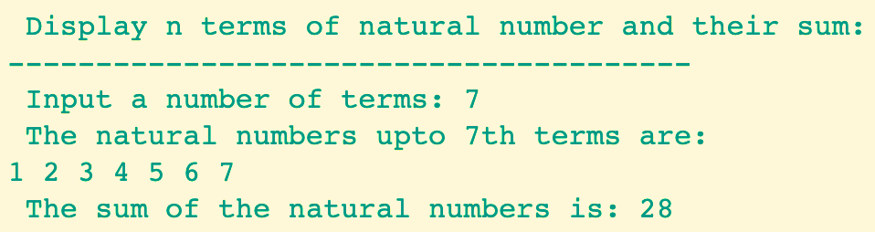

#include <iostream>
using namespace std;
int main()
{
int n,i,sum=0;
cout << "\n\n Display n terms of natural number and their sum:\n";
cout << "---------------------------------------\n";
cout << " Input a number of terms: ";
cin>> n;
cout << " The natural numbers upto "<<n<<"th terms are: \n";
for (i = 1; i <= n; i++)
{
cout << i << " ";
sum=sum+i;
}
cout << "\n The sum of the natural numbers is: "<<sum << endl;
}

