Making Graphs and Linear Regression

Enter the following data into a spreadsheet:
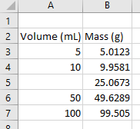

Highlight the numerical data. When you make a plot, the x-axis is the column to the right of the y-axis. This can be fixed later, but it’s something to keep in mind when you’re organizing your data.
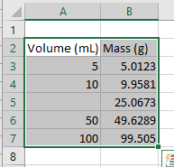

Click Insert and then go to the Charts toolbar and click scatter
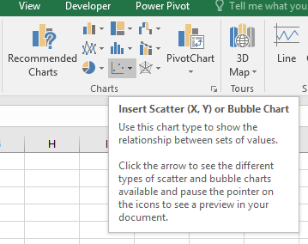
From scatter chart options, choose Scatter
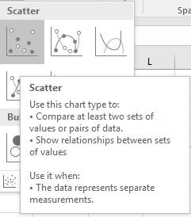

The following graph will appear in your workbook:
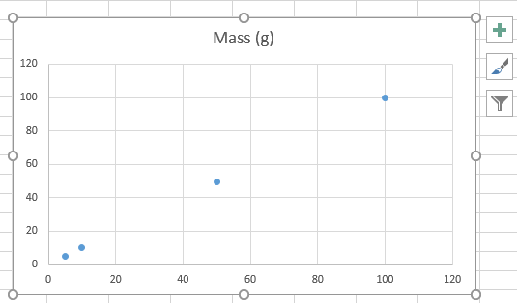

Notice that, the axes are not labeled, and the axes are hard to see. Let do some formatting:
- Click on the y-gridlines extending across the graph, and hit delete.
- Click on the x-gridlines extending across the graph, and hit delete.
- Click on the Title box to edit it and type “Volume of Water at Room Temperature vs. Mass”.
- Left click on your chart and go to Design Tab Add chart Elements Axis Titles Primary horizontal. In the inserting function box type “Volume, mL”.
- Left click on your chart and go to Design Tab Add chart Elements Axis Titles Vertical horizontal. In the inserting function box type “Mass, g”
- Left click on your chart and go to HOME tap and change the font to “Time New Romans” and make the font size 12.
- Change the font size of numerical data on x-axis and y-axis by left clicking on them and go to HOME tap make the font size 11.
After you’ve completed all these steps, your graph should look like this:
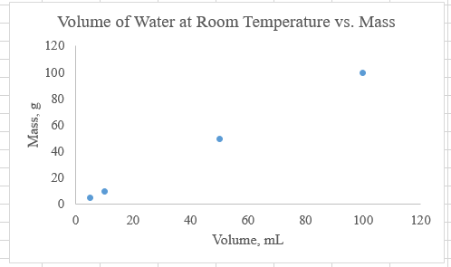

Adding a Trendline
Left click any point on your chart one click and once you activate them, make a right click and choose Add Trendline. From format Trendline scroll down and check “Display Equation of chart” and “Display R-squared value on chart.
After you’ve completed all these steps, your graph should look like this:
