As a new TA who wants to use WebCAT, What should you do?

WebCAT is located at:
http://10.131.240.28:8080/Web-CAT/WebObjects/Web-CAT.woa/
and accessible only from CCIS network (or through KSU VPN if you want from home)

A. The following is done only once at the beginning of the semester

- Create a course offering for each one of your lab sections:
After you login into WebCAT, go to Courses new. Choose semester Fall 2015. Use following way to name the section (course offering):
field CRN: F15-sec_num
field label: F15-sec_num-Dr_first_name-TA_first_name-day_from_to
Example:
field CRN: F15-12345
field label: F15-12345-Muath-Sultan-SU_10_12
this is section number 12345 with Dr Muath and TA Sultan on Sunday from
10 to 12 in fall 2015.

- Upload a student roster (i.e., list) for EACH course offering (i.e., each lab section):
Roster should be a CSV (comma separated format) file (there is a sample file named roster-example.csv under Google drive: CSC111_material->webcat-grading-system). You can edit/create such file using MS Excel (just make sure you save as Comma Separated Format or CSV). You can copy data from students list from EDUGATE. Each row in the roster should contain 6 columns as following:

First name | Last name | Ksu Email | Student ID(username) | Student ID | Student ID(password)

ADD YOURSELF AS A STUDENT to the roster so that you can login later as one of your students and check your assignments and lab exams.
Here is how to upload the roster:
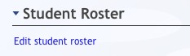

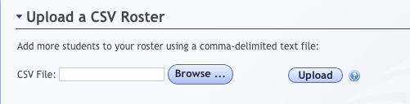

When you finish uploading, you should see the list of the students

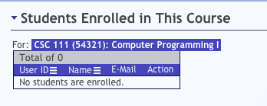

B. Creating assignment is done:
- once for ALL sections per lab/assignment and
- once per each section per each labExam

Each week one TA will be asked to create the Assignment on WebCAT for the lab/assignment for all sections. On the other hand, one Assignment will be created on WebCAT for each lab exam for each section. This is since each section will have different question/testcase/time when it comes to lab exam.
IMPORTANT: if an assignment is created before a section is created then it has to be reoffered (Assignment new re-offer existing assignment)to that section. This happens usually beginning of semester only. From that time on, once an assignment is created for all sections, it will appear for all sections.

How to create an assignment? After you login, go to Assignments menu on top of page and click new

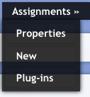

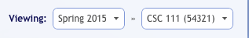
  - If it is a lab exam then make sure it is under only one of your own course offering (i.e., one of your own course sections). See above it is under section 54321.

  - Otherwise for lab and assignments and since they are the same for all sections, make it under all sections so that you share it with other TAs (this way they do not have to create their own except if they created their section or course offering after you created the assignment in which case they have to re-offer it).

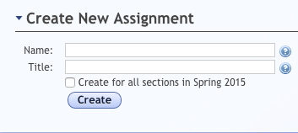
For assignment:
Name: F15-Assignment - #
Title: General Description
For lab:
Name: F15-Lab - #
Title: General Description
For lab exam:
Name: F15-Exam#-yoursectionnumber
Title: Dr_first_name-TA_first_name-day_from_to

Remember the student will see the name along with the title when he tries to submit.

C. Creating submission rules for assignment

- Use lab submission rule for labs/assignments and lab exam submission rule for lab exam.

Only proceed to the following discussion on how to create a new submission rule when you are sure you need to create a new one.

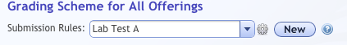

Set the submission rules as you wish (50% you, 50% the system for example). Set start accepting to blank for lab/assignment since we do not care about due date here. For exams it should be 2 hours (i.e., start accepting 2 hours before exam due date and time). Remember that we set due date for assignment offering not assignment.

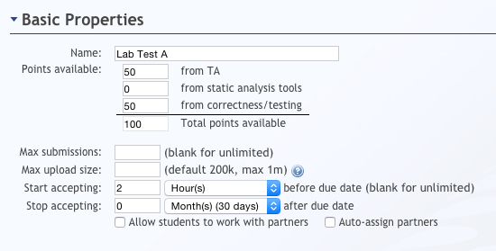

D. Uploading a testcase

- Go to plugin to upload Test case file (testcases are provided in google drive). Make sure to a new JavaTddPlugin is created(just one plugin) then click on gear icon to open upload page.

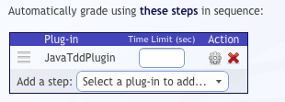

- Upload the test case under (JUnit Reference Test Class(es)) by clicking on browse and choosing the file. After you upload the testcase, you do NOT need to upload anything under the other two entries (see picture below).

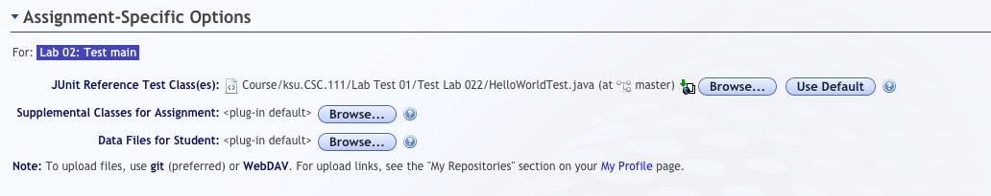

- Make sure you change the choose lab (All Sections) for setting for grading plugin. You do not need to create a new one. Here are the used settings
- No need for student provided test.
- No need for static checking for style.

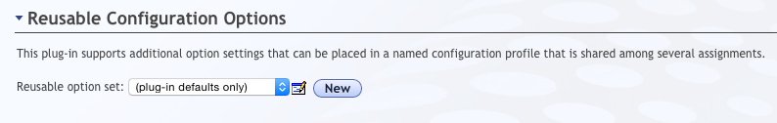

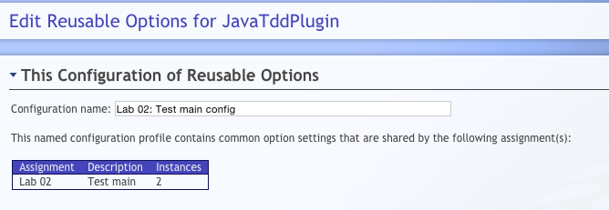

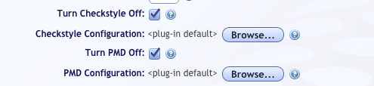

- Make sure you save all settings

E. Creating an assignment offering

- Assignment offering allows you to have specific due dates for different sections. After an assignment is created (either by you or others), you will have an assignment offering where you can specify due date and time. Except for lab exam, all offerings should have the same due date and time (i.e., we use the lock icon next to Due Date see picture below)

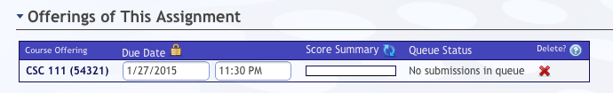

- Publish your assignment

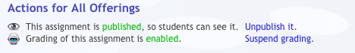

F. Submitting assignments using Eclipse

Eclipse plugin is installed in the lab. There is one step, which student needs to do one time only. Each student should set up the Electronic Submission URL as following:
Go to Window -> preferences -> Electronic Submission

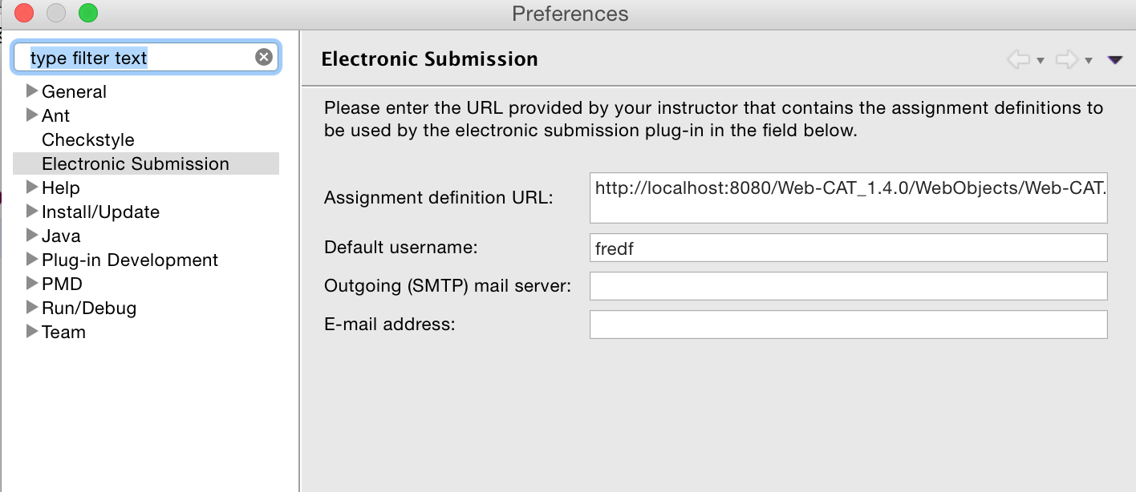

Enter the following URL (one line please)
http://10.131.240.28:8080/Web-CAT/WebObjects/Web-CAT.woa/wa/assignments/eclipse

After that, when a student is done with his lab right click on the project and click submit.
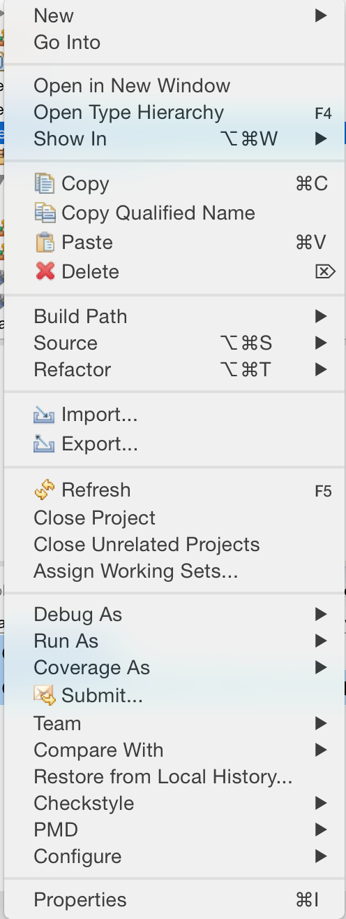

Then student should pick up the assignment, enters his username and password and then clicks Next. Then clicks Finish.

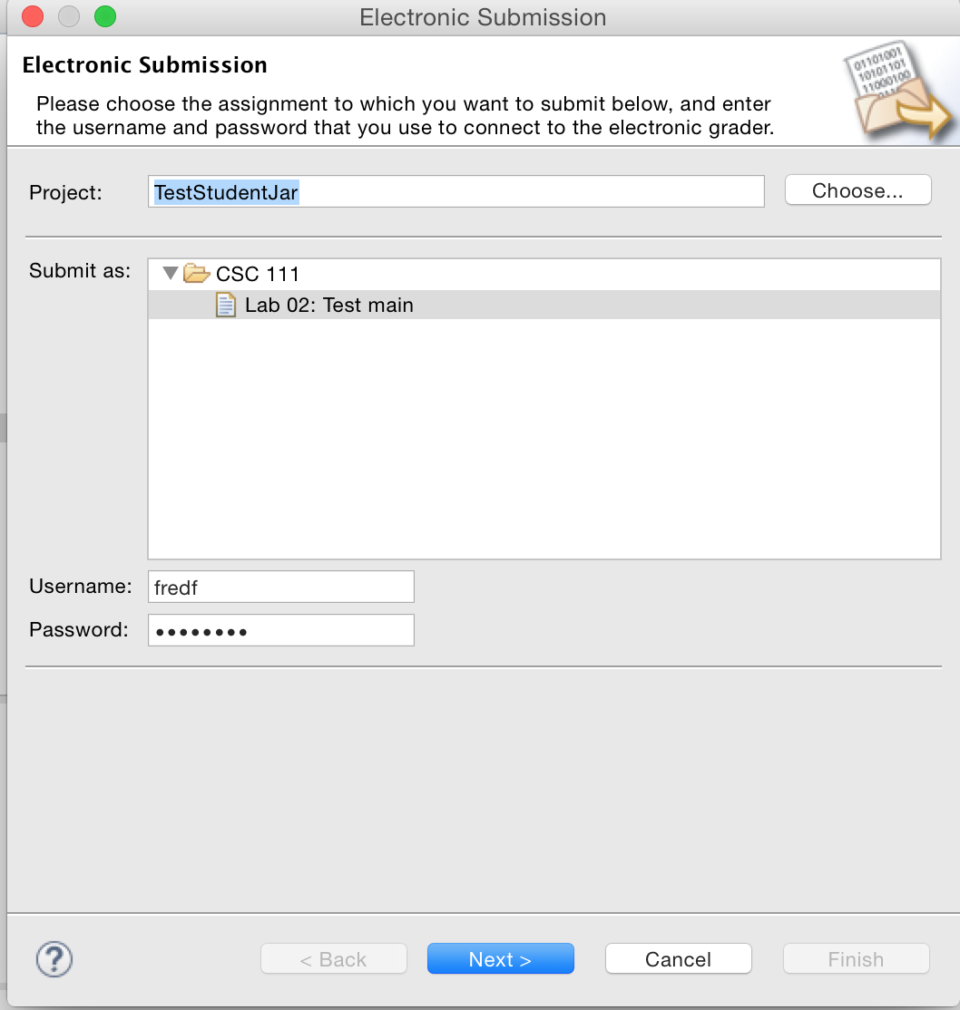

The student is going to get his grade inside a window in eclipse after that. The grade window is similar to the following:

