Vital Signs Outline
Dr. Monirah Albloushi

Objectives
By the end of this presentation you will be able to:
Define the concept of vital signs and times to assess vital signs.
Identify factors affecting changes in vital signs.
Define terms and abbreviations used when assessing vital signs.

Vital Signs:
Measurement of the functioning of vital (necessary for life) organs of the body: heart, lungs and blood vessels.
- Temperature
- Pulse
- Respiration
- Blood pressure (B/P)
- Oxygen saturation
- Pain
Vital signs may reveal sudden changes in a client’s condition in addition to changes that occur progressively over time. Baselines sets of VS are important to identify changes in the patient’s condition.

Vital signs are part of a routine physical assessment and are not assessed in isolation. Other factors such as physical signs & symptoms are also considered.
Important Consideration:

A client’s normal range of vital signs may differ from the standard range.

When to take vital signs
- On a client’s admission.
- According to the physician’s order or the institution’s policy or standard of practice.
- Before & after a surgical or invasive diagnostic procedure.
- Before & after the administration of meds or therapy that affect cardiovascular, respiratory & temperature control functions.
- Changes in the level of consciousness, pain.
- Before, after & during nursing interventions influencing vital signs.
- When client reports symptoms of physical distress.

Body Temperature
Core temperature – temperature of the body tissues, is controlled by the hypothalamus (control center in the brain) – maintained within a narrow range.
Skin temperature rises & falls in response to environmental conditions & depends on blood flow to skin & amount of heat lost to external environment.
The body’s tissues & cells function best between the ranges from 36 C -38 C (degrees Celsius) / 96.8 F- 104 F( Fahrenheit)
Temperature is lowest in the morning, highest during the evening.

Temperatures can be increased by:
Infection, illness.
Dehydration (lack of fluids).
Physical exercise.
Intake of hot liquids.
Extremely warm environment.
Emotions such as crying.

Temperatures can be decreased by:
- Shock.
- Cold environment.
- Medications.

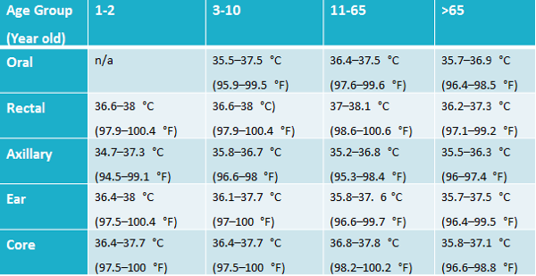

Pulse
Pulse is the expansion and contraction of an artery (blood vessel).
Rate of Pulse – number of beats per minute.
Pulse rate indicates how fast the heart is beating.
Pulse rate may be measured at several body sites.
Radial (wrist) pulse is most common site.

Rate varies with individuals – depends on age, sex, body size and exercise.
Usually pulse rate goes up as temperature increases.
Normal adult resting rate if 60-80 beats per minute.
Pulse rates of the elderly are affected by disease conditions and some medications.
- Under 60 bpm is bradycardia
- Over 100 bpm is tachycardia.
Age | Heart Rate (Beats/min)
Infants | 120-160
Toddlers | 90-140
Preschoolers | 80-110
School agers | 75-100
Adolescent | 60-90
Adult | 60-100

Respiratory Rate
Respiration is the body process of breathing which
Supplies the body with oxygen and releases carbon Dioxide.
Respiration includes
- Inspiration (breathing in).
- Expiration (breathing out).
Normal respirations:
- Adults – 12-22 per minute.
Respirations increase with
- Infection and some chronic diseases.
- Fever (elevated temperature).
- Some heart, lung and blood vessel diseases.
- Emotional upsets, stress, crying.
- Exercise or activity.
Respirations decrease with
- Some medications and diseases.

Respiratory Rate

Rate | Number of breathing cycles/minute (inhale/exhale-1cycle)  N – 12-20 breaths/min – adult - Eupnea – normal rate & depth breathing  Abnormal increase – tachypnea  Abnormal decrease – bradypnea  Absence of breathing – apnea  Ddifficult or labored breathing -Dyspnea
Depth | Amount. of air inhaled/exhaled  normal (deep & even movements of chest)  shallow (rise & fall of chest is minimal)  SOB shortness of breath (shallow & rapid)
Rhythm | Regularity of inhalation/exhalation  Normal (very little variation in length of pauses b/w I&E

Blood Pressure
Force exerted by the blood against vessel walls.
- Systolic: Force exerted against the arterial wall as lt.
- Diastolic: Arterial pressure during ventricular relaxation, when the heart is filling, minimum pressure in arteries.
Factors affecting B/P
- Lower during sleep
- Lower with blood loss
- Position changes B/P
- Anything causing vessels to dilate or constrict - medications
Measured in mmHg – millimeters of mercury
Normal range
- Systolic 110-140
- Diastolic 60-90
- Hypertension >90
- Hypotension <90
Precautions
Do not take B/P in;
- Arm with cast
- Arm with arteriovenous (AV) fistula
- Arm on the side of a mastectomy i.e. right mastectomy, right arm
Oxygen Saturation (Pulse Oximetry)
Non-invasive measurement of oxygen saturation
Calculates SpO2 (pulse oxygen saturation) reliable estimate of arterial oxygen saturation
Probes – finger, ear, nose, and toe
- Normal – 90-100%
Pain – The Fifth Vital Sign
Pain is regularly and frequently evaluated.
Pain rating scales are 0-10 with 10 the most severe.
Observe patient for pain when moving, facial expressions, crying, moaning, rigid posture, restless, and refusal to eat.
Cultural responses to pain varies.

Terms:
Blood Pressure | Measurement of the force of the blood against  the walls of the arteries.
Systolic Pressure | Number at which the first sound is heard
Diastolic Pressure | Number at which the last sound is heard
Hypertension | High blood pressure; greater than 140/90.
Hypotension | Low blood pressure; lower than 90/50

Temperature | Measurement of body heat.
Fever | Elevated body temperature.
Pulse | Expansion and contraction of an artery.
Pulse Rate | Measures heart beats per minute.
Pulse Spots | Areas on body where pulse can be counted or  measured.
Respirations. | The process of breathing  the exchange of gases (oxygen and carbon dioxide) in the lungs.

