_____

- Create a dynamic object to the following class then try to set the class members to 10 and ‘b’ respectively.
class MyClass
{public:
int m_Number;
char m_Character;
};

- Write the code fragment
  - Create pointer p to point to an array of string a
  - How to access the first element of array using the pointer
  - How to change the pointer address to be pointed to the second element of the array a.
  - The following figures :

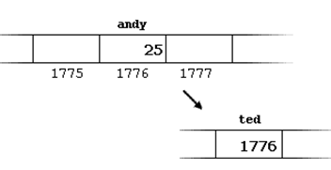

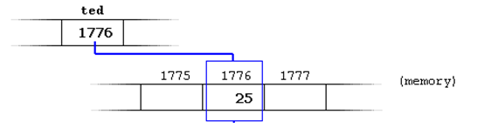

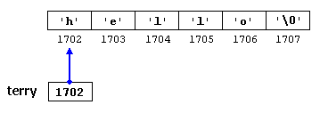

- Tracing the output.

- int anArray[5] = { 9, 7, 5, 3, 1 };
cout << *(anArray+1) << endl;

#include <iostream>
using namespace std;
void bill(int x, int *y)
{
cout << "The arguments passed to bill are x ="<< x << " *y = " << *y<<endl;
x = x + 5;
*y = *y + 5;
cout << "The arguments after being modified are x ="<< x << " *y = " << *y<<endl;
}
void main( )
{
int a = 5;
int b = 10;
cout << "The values before bill called are a ="<<a<<", b ="<< b<<endl;
bill (a,&b);
cout << "The values after bill are a ="<<a<<", b ="<< b<<endl;
}

- #include <iostream>
using namespace std;

int main ()
{
int numbers[5];
int * p;
p = numbers; *p = 10;
p++; *p = 20;
p = &numbers[2]; *p = 30;
p = numbers + 3; *p = 40;
p = numbers; *(p+4) = 50;
for (int n=0; n<5; n++)
cout << numbers[n] << ", ";
return 0;
}

