EXAMPLES:

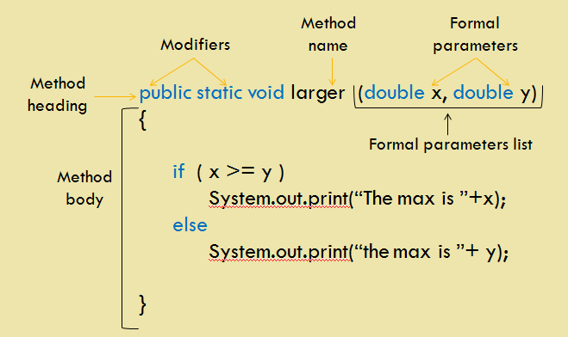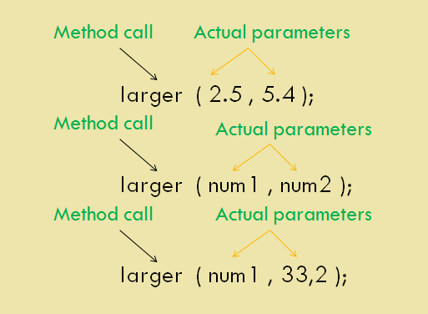
- Write a method called larger that accepts two double parameters and
returns the larger of the two.

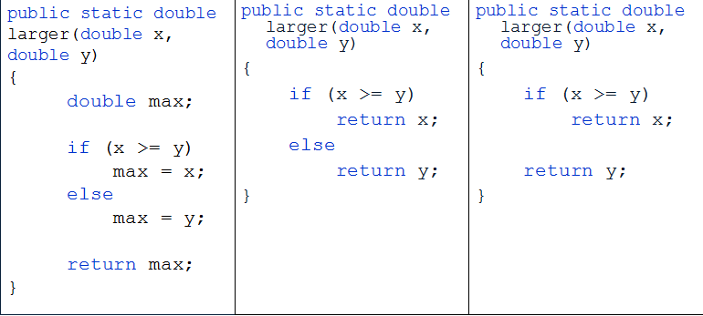
EXERCISES:

- Write a method called smallest that accepts two integer parameters and returns the larger of the two.
- Function Voting takes the age and return true or false.
If the age is above 18 he can vote, other wise they cant drive
- Function age take the birth date and then calculate the age in year and the months and days for user and print them
Example :
Enter your birth year : 1990

You are 24 years old
288 Months , 8640 days .
- Write a method called countA that accepts a String parameter and returns the number of times the letter 'A' is found in the string.

- Over loaded function volume to cal calculate the volume of cube and for cylinder and print the result.
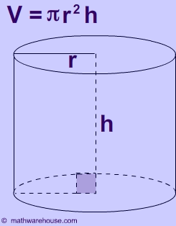
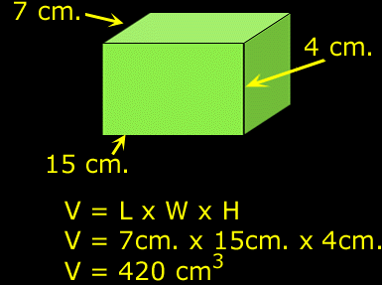
Hit:

