_____
- Create a dynamic object to the following class then try to set the class members to 10 and ‘b’ respectively.
class MyClass
{public:
int m_Number;
char m_Character;
};

- Write the code fragment
  - Create pointer p to point to an array of string a
  - How to access the first element of array using the pointer
  - How to change the pointer address to be pointed to the second element of the array a.
  - The following figures :

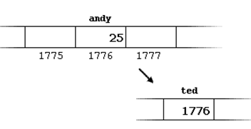

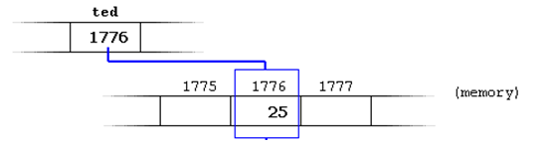

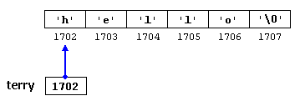

- Write a program to do the following :in main

- ask the user to enter an array size
- call function create to create an array of string dynamically
- Then call a function Enter to fill the array with names
- Then print the array content (in main )

Function Create takes one parameter (the array size)
Inside the function create the array dynamically and return pointer to that array

Function Enter takes two parameter (pointer to array of string and the array size)
Inside the function ask the user to fill the array with names

