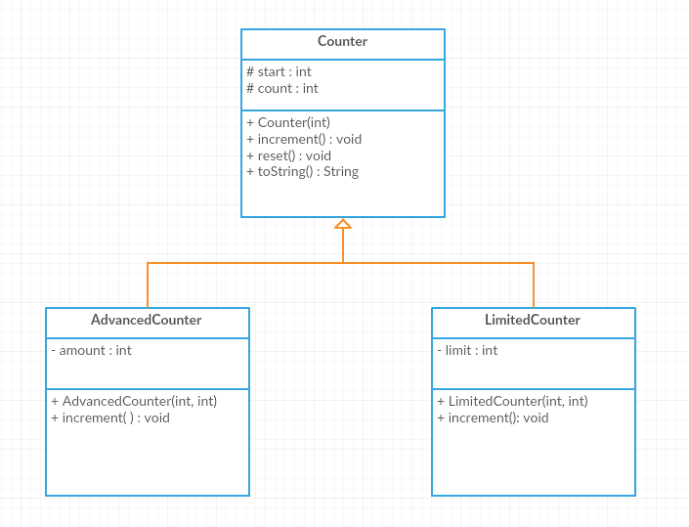

Counter class:
Attributes:
- start: starting value of the counter
- count: the current value of the counter
Methods:
- Counter(value: int): constructor
- increment(): this method increments the count by one
- reset(): this method resets the count to its starting value
- toString(): this method returns the object info in the following format ‘( count )’

AdvancedCounter class:
Attributes:
- amount: the amount to increment the count with
Methods:
- AdvancedCounter(value: int, amount: int): constructor
- increment():this method increments the count by amount

LimitedCounter class:
Attributes:
- limit: the upper limit that the counter stops at
Methods:
- LimitedCounter(value: int, limit: int): constructor
- increment(): this method increments the count by one only if the limit hasn’t been reached. It prints a message saying the limit has been reached otherwise.

Exercise 1: Translate into Java-code the class Counter, AdvancedCounter, and LimitedCounter.

Exercise 2: Write a test class with a main method and do the following:
- create three objects of type Counter, AdvancedCounter and LimitedCounter
- increment the three of them once
- print the value of the counter for each
- increment the LimitedCounter object to its limit
- reset it and print its value

