Tutorial # 4

Question#1: Trace the following code

(a)

Input 1 Input 2
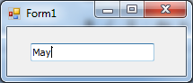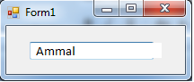

Dim word As String = TextBox1.Text
Dim firstLetter, secondLetter As String
Dim flag As Boolean = True

For i As Integer = 0 To word.Length - 2

firstLetter = word.Substring(i, 1)
secondLetter = word.Substring(i + 1, 1)

If firstLetter = secondLetter Then
txtOutput.Text = "Equal letters, first = second letter = " & firstLetter
Exit For
End If

If i = word.Length - 2 Then
txtOutput.Text = "This word has no repeated letters" End If

Next

Trace of Input 1

i | firstLetter | secondLetter | txtOutput.Text

Trace of Input 2

i | firstLetter | secondLetter | txtOutput.Text

(b)

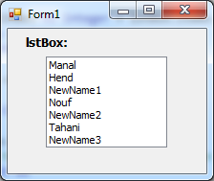

Dim highestIndex As Integer = lstBox.Items.Count - 1
Dim Name As String
Dim i As Integer = 0

Do While i <= highestIndex

Name = CStr(lstBox.Items(i))
i += 1

If Name.StartsWith("New") Then
txtOutput.Text &= "Exit Do Name = " & Name & vbCrLf
Exit Do
Else

txtOutput.Text &= "Continue Do Name = " & Name & vbCrLf
Continue Do
End If

Loop

i | highestIndex | Name | txtOutput.Text

Question#2: What is the output of the following?

(a)

Dim var2 As Integer

For var1 As Integer = 0 To 2

If var1 = 1 Then
txtOutput.Text &= "Continue For" & vbCrLf
Continue For
End If

var2 = 0

Do While var2 < 3

txtOutput.Text &= "var1 = &" & var1 & " var2 = " & var2 & vbCrLf

If var2 = 2 Then
txtOutput.Text &= "Exit Do" & vbCrLf
Exit Do
End If

var2 += 1

Loop

Next

txtOutput.Text

(b)

Dim number, copy As String, position As Integer number = "123.4567"
copy = number
position = number.IndexOf(".")

txtLeft.Text = number.Substring(0, position)
txtRight.Text = number.Substring(position + 1, number.Length - 1)

txtLeft.Text =........................., txtRight.Text =.............................

(c)
Input1 Input2

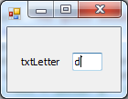
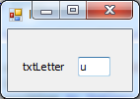

Dim sentence = "THE QUICK BROWN FOX JUMPS OVER A LAZY CAT" Dim letter As String
Dim position As Integer
letter = txtLetter.Text.ToUpper position = sentence.IndexOf(letter)
txtOutput.Text = letter & " first occurs in position " & position & "."

txtLetter.Text | txtOutput.Text
u
d

