Create a website like the figure below:
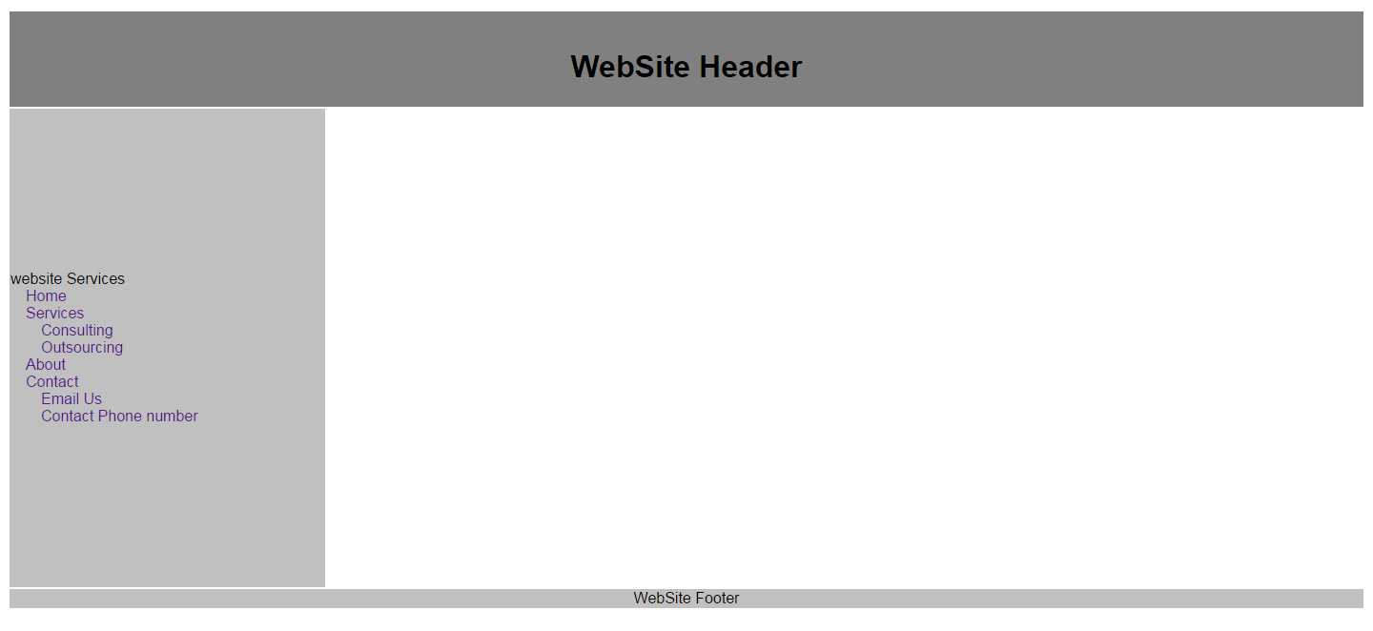
Section that changes on a page by page basis

80 px
800 px
500 px  150 px | 650 px

