public class rectangle {
private double length;
private double width;
//default constructor
public rectangle() {length=width=0; }
public rectangle( double w , double l)
{ setdimension(w,l); }
public void setdimension( double w, double l)
{width=w; length=l; }
public double getw(){return width;}
public double getl(){return length;}
public double area(){ return width*length;}
public void print()
{System.out.println("length =" + length+"width = " + width );}
}

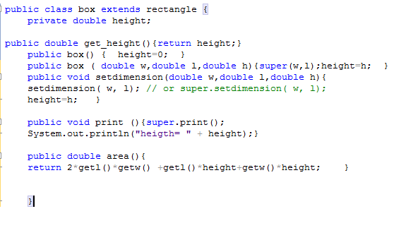

Complete on rectangle box classes program in main
- Create two objects of class rectangle one with the default constructor and one with the copy constructor.
- Create two objects of class Box one with the default constructor and one with the copy constructor.
- Try to call function print from the class rectangle from objects of type box.
- Print the content of the 4 objects with calling area function each time.

