Sheet # 8
Question#1: Write a vb.net program:
- Using different controls as shown bellow in Form1, write a program that reads the selected inputs from Form1 then displays it in a message box.
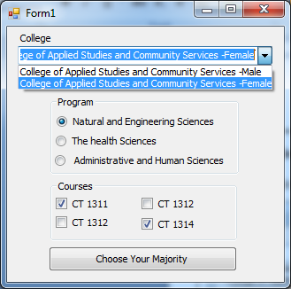
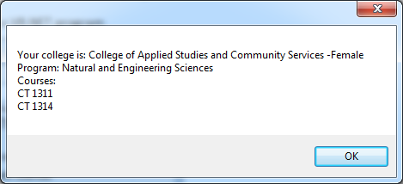
Input Output

- Write a program that change the back ground color of a text box that has a text "Visual Basic", based on the selected color in the radios button. The back ground color should change once the user click on his selection in the radios button.
Then display a tooltip for the text box as shown below

