- Define a 5 elements array and fill it with user input , swap between the first element and the last element then print the array content again.

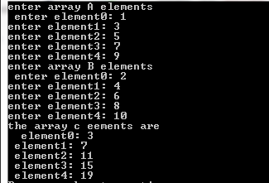

- Write a program that will:
- Declare three arrays A,B and C all of type integer and size 5 .
- Read elements of array A and array B from the user.
- Add the elements of array A and array B to array C .
- Displays all the elements of array C.

