Question #1: Write a VB program that takes as input a string and displays the string with every even index of letters capitalized.
The processing must be in a subroutine procedure and the result should be displayed in the event procedure (button click).
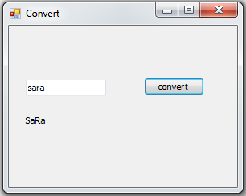
Question#2: Write a program that displays the number of reward points a customer earns each month. The reward points are based on the customer’s membership type and total monthly purchase amount.
Create 2 functions or subroutines called (Total and Print) to make the following:
- Total -> Make all the calculations.
- Print -> Print only the result.
Membership Type | Total monthly purchase ($) | Reward points
Basic | Less than 75 | 5% of total monthly purchase
 | 75 – 149.99 | 7.5% of total monthly purchase
 | 150 and over | 10% of total monthly purchase
Standard | Less than 150 | 6% of total monthly purchase
 | 150 and over | 13% of total monthly purchase
Premium | Less than 200 | 7% of total monthly purchase
 | 200 and over | 15% of total monthly purchase

