**Sheet # 4**

**Question #1:** Write the following Programs in Visual Basic:

1. ***(Factorial of a Number)*** Write a program that calculates the factorial of a number using one of the repetition statements that you have learn. Example the factorial of number 3 is 6 (because: 1 x 2 x 3 = 6).



1. ***Decimal to Binary Convertor)*** Write a program that reads from the user a decimal number and then displays its corresponding binary number. For example, if the user enters the decimal number 4 the program should output its corresponding binary numbers respectively: 100. (Hint Use the Mod operator to help you in calculating the binary number). The output should look a follows:

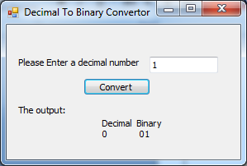 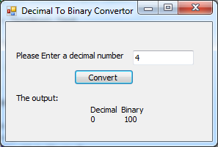

1. ***(Multiplication Table Creator)*** Write a program that reads a number then displays the multiplication table of all numbers equals or less than that number. For example when the user select number 3 the output in the textbox should display multiplication tables of 1, 2, 3. The output should look like the following:

