Write a program

- Write a program to ask the user to enter two numbers and to decide what to do with them ask him to enter 1 for adding and 2 for subtraction 3 for multiply and 4 for division(in case of division make sure the second number is not 0)
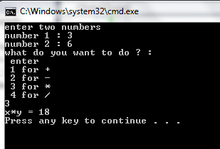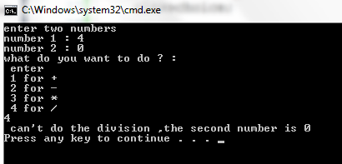

  - repeat the previous question using switch

- Write a Java program that ask the user to enter a number then determine whether an input number is an even number or not
Example:
Enter a number : 6
This is an even number
Enter a number : 3
This is an odd number

- Write a Java program that determines a student’s grade.
The program will read three types of scores(quiz, mid-term, and final scores) and determine the grade based on the following rules:
-if the average score >=90% =>grade=A
-if the average score >= 70% and <90% => grade=B
-if the average score>=50% and <70% =>grade=C
-if the average score<50% =>grade=F
Example:
Quiz score: 80
Mid-term score: 68
Final score: 90
Your grade is B.

- Write a Java program to calculate the revenue from a sale based on the unit price and quantity of a product input by the user.
The discount rate is 10% for the quantity purchased between 100 and 120 units, and 15% for the quantity purchased greater than 120 units. If the quantity purchased is less than 100 units, the discount rate is 0%.
Example:
Enter unit price: 25
Enter quantity: 110
The revenue from sale: 2750.0$
After discount: 275.0$(10.0%) The revenue will be : 2475.0$

