**Question #1:** Write the following Programs in Visual Basic:

1. ***(Multiples)*** Write an application that reads two integers and determines and prints whether the first is a multiple of the second. For example, if the user inputs 15 and 3, the first number is a multiple of the second. If the user inputs 2 and 4, the first number is not a multiple of the second. [Hint: Use the Mod operator.]



1. Write a program that reads three nonzero double values and determines and prints if they could represent the sides of a triangle. In the triangle : third side2=first side2+second side2

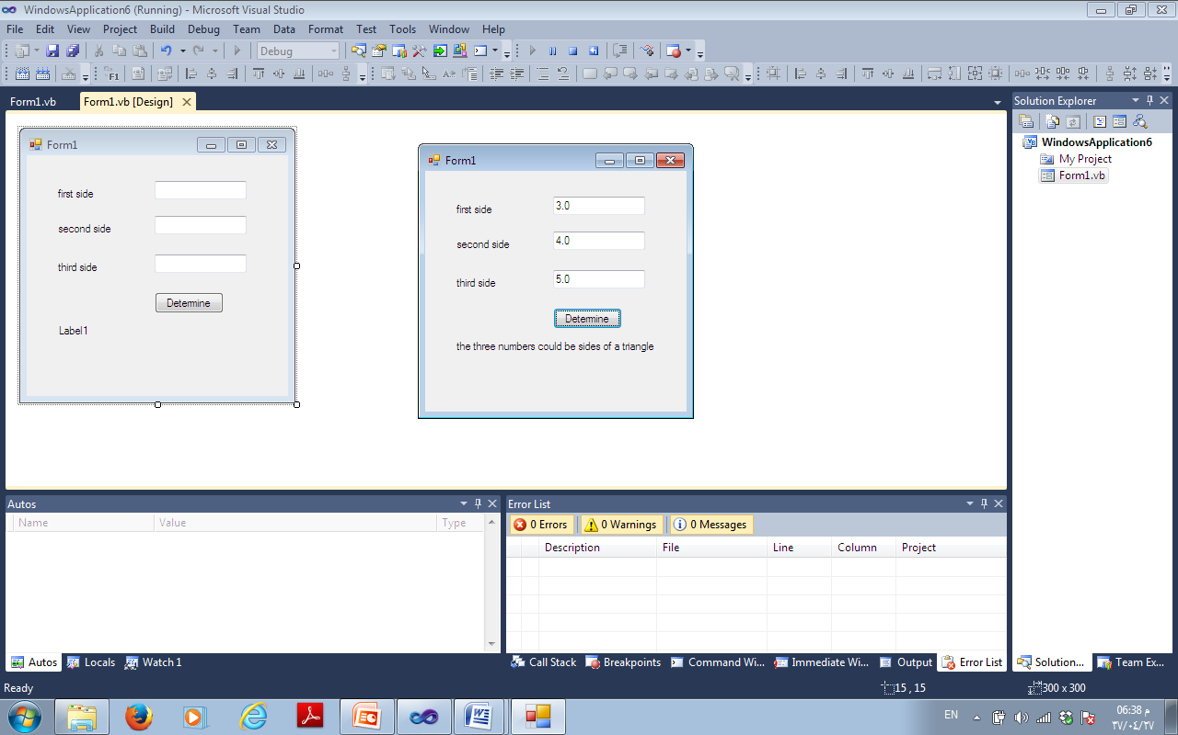

1. (Solve it by Select…Case Multiple-Selection Statement )Write a program that reads the price And the production date(month and year of an item) then prints the price after applying the discount rate which equals to:

* 50% if it is produced before 2015.
* 30% if it is produced in 2015 but before the 4th month.
* 10% if it is produced after 4,2015 and before 7,2015
* Otherwise, No discount is calculated.

