Good programming practice:
- Start your program with a comment
- The last character printed in any output statements should be a new line
- Indent your code to make it more readable

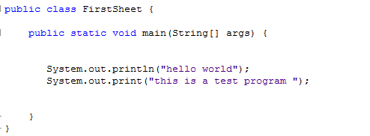
Q1. Edit, compile and run the following program, and observe the output produced.

Evaluation : Q2. Write a program that print your full name in a line and your ID number in another line.
HW : Q2. Write a program that prints some information formatted as shown below
