Using Visual Basic:
- Write a project that has this question “what is the visual basic?” then when a user press the button, the program will show this answer “It is one of the visual studio package” and a picture .
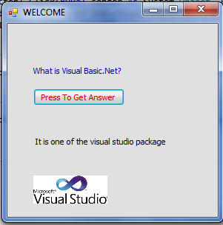
Your program should be seems like Figure 1

Fig.1
******************************************
2. Write a project that allows the user to enter two numbers then calculate math operations (-,*,/,\,mod,^) of the numbers

