Name: ………………………………………………………. I.D:………………………………..………………
SDS-Polyacrylamide Gel Electrophoresis

-Determine the molecular weight for the protein sample in (lane 1), using the following information and drawing the standard curve of known proteins molecular weights:
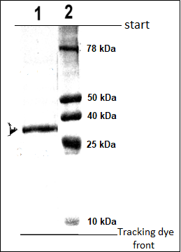
Note that:
[1] Protein sample with unknown molecular weight.
[2] Standard of known proteins molecular weights, see the following table:

Fill the following table with the information which will help you drawing the standard curve
? | ? | MW (Da)
 |  | 78,000
 |  | 50,000
 |  | 40,000
 |  | 25,000
 |  | 10,000

The molecular weight of the protein sample in (Lane 1) is ?(details is required)
…………………………………………………………………………………………………………………………………………………………………………………………………………………………………………………………………………………………………………………………………………………………………………………………………………………………………………………………………………………….………………………………………………………………………………………………………………………………………………………………………………………………………………………………………………………………………………………………………………………………………………………………………

What is the function of each material?
1-Disruption buffer:
SDS, Glycerol, β-Mercaptoethanol and Bromophenol blue.
2- Acrylamide stock.
3- Stacking gel.
4-Separation gel.
5-Running buffer.
6-Staining buffer: Coomassie brilliant blue R- 250.
7-De-staining buffer.
8-Ammonium persulphate.
9-TEMED.

