# PHCL-435

### Name:------------------------------------------

### ID:----------------------------------------------

-----------------------------------------------------------------------------------------------------------------------------------------

# Question 1: Mark (T) for true or (F) for false

A. Descriptive statistics isMethods and procedures for summarizing and inferring data

( F )

B. Inferential statistics is defined asMethods used to make statements about population based on information gathered from sample withdrawn from this population. ( T )

C. Measures of central tendency are Mean, Median and Mode. ( T )

D. The relationship of the sample size and standard error of the mean is directly proportional. ( F )

E. Standard deviation is used when presenting your results to people with little or no knowledge of statistics. ( F )

F. Box plot is used for comparing and for defining the outliers.( T )

G. Standard error is always smaller than standard deviation. ( T )

# Question 2: choose the correct answer:

**1. One of the following can be used for both numerical and ordinal data**

**BUT NOT nominal**

a. Mean.

b. Median.

c. Mode.

d. None of the above.

**2.One of the following is NOT CORRECT regarding MODE:**

a. Can be applied for both numeric and categorical.

b. Data set can have one, 2 or more modes.

c. Data set can have NO mode at all

d. Mode is the arithmetic average.

**3. Measures the dispersion (or spread) of figures around the mean.**

a. Variance.

b. Variation coefficient.

c. Standard deviation.

d. Standard error of the mean.

**4. Compare variability of a variable in two different sets of data**

a. Mean.

b. Standard deviation.

c. Variability coefficient.

d. None of the above.



**5. This scatter graph shows you the relationship between head circumference and forearm length, what kind of relationship this graph shows?**

a. linear relationship between the variables.

b. No relationship.

c. Exponential relationship.

d. Inverse relationship.

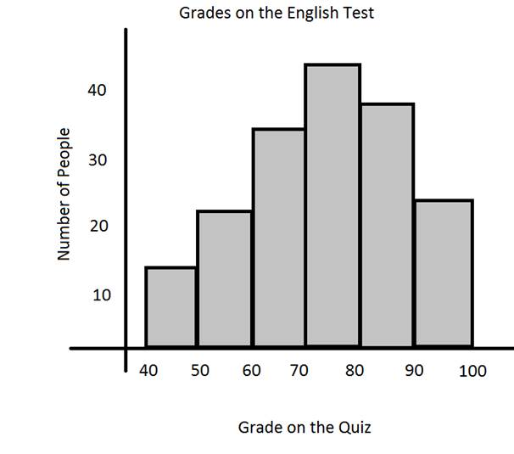

**6. this plot is called....................... it is used for........................**

a. Bar chart---used to identify data shape.

b. Histogram---used to identify data shape.

c. Histogram---used for small data sets.

d. Bar chart....used for measurement data.