King Saud University
College of applied studies and community services

revision

Question
A program is needed to calculate blood sugar level and diagnosis for a 10 patients.
Then display it on the screen. The program should do the following:
- Prompt the user to enter a patient's:
- patient's name
- number of blood sugar readings
- blood sugar levels (Store the blood sugar level readings in array)

- Calculate the average for the sugar readings.

- diagnose the patient's disease as :
- If average is between 70 to 107, Diagnosis = Normal.
- If average is between 108 to 126,Diagnosis = Pre-diabetes.
- If average is more than 126, Diagnosis = diabetes.

- Display the patient's name, average readings, and diagnosis.
Sample Run examples

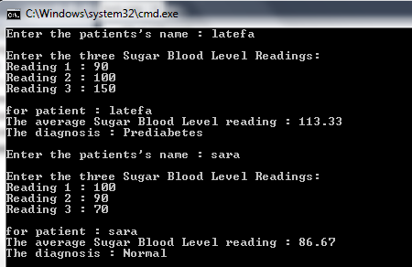

Assume you have 2 sections each section contains number of students.

Write a program that do the following for each section :

- Read the student’s grade from the user.
- Then show wither the student is passed or failed (to pass the course the students grade should be 60 or above).
- Print the total and the average of the grades along with the minimum and maximum grades.

