MIDTERM EXAM 1

Student Name:

ID:

**Computer Engineering Department**

**College of Computer and Information Sciences**

**Instructor: Dr. Kashif Akhtar Saleem**

**Course Code: CEN 445 Duration: 1 and half hour**

**Course Name: NETWORK PROTOCOLS AND ALGORITHMS Date: July 3, 2013**

**Semester: Summer Semester 33/34**

**Problem 1**

Choose the most suitable answer.

1. Which answer correctly lists the OSI PDUs in order?

A. Data, Packet, Frame, Segment, Bit

B. Bit, Data, Packet, Segment, Frame

C. Data, Segment, Packet, Frame, Bit

D. Bit, Frame, Segment, Packet, Data

2.Logical addressing is found in the ________________ layer, while physical addressing is found in the ________________ layer.

A. Physical, Network

B. Network, Physical

C. Data Link, Network

D. Network, Data Link

3. The OSI Reference Model layers, in order from top to bottom, are:

A. Application, Physical, Session, Transport, Network, Data Link, Presentation

B. Application, Presentation, Network, Session, Transport, Data Link, Physical

C. Physical, Data Link, Network, Transport, Session, Presentation, Application

D. Application, Presentation, Session, Transport, Network, Data Link, Physical

4. Build a simple network

a. Build a simple star topology based network like the figure below using the packet tracer.

b. Set the IP address information for each PC according to the information in the table.

|  |  |  |  |
| --- | --- | --- | --- |
| Computer | IP Address | Subnet Mask | Default Gateway |
| PC1 | 192.168.0.101 | 255.255.255.0 | 192.168.0.1 |
| PC2 | 192.168.0.102 | 255.255.255.0 | 192.168.0.1 |
| PC3 | 192.168.0.103 | 255.255.255.0 | 192.168.0.1 |
| PC4 | 192.168.0.104 | 255.255.255.0 | 192.168.0.1 |

5. Data link layer: move frames from ________________________________________

**Problem 2**

1. Define the following terms:

a. Network layer

b. NIST, IEEE and IETF

c. Routing Algorithms

1. Network Layer Design Issues (there are 5 named 2 of them)

2.

1. Mention the missing wordings.

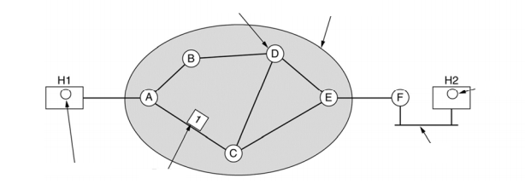

1. Packet Switching? What are two Two connection types?
2. Connection‐Oriented or Connectionless?

**Problem 3**

1. Give two example computer applications for which connection-oriented service is appropriate. Now give two examples for which connectionless service is best.
2. Datagram subnets route each packet as a separate unit, independent of all others. Virtual-circuit subnets do not have to do this, since each data packet follows a predetermined route. Does this observation mean that virtual-circuit subnets do not need the capability to route isolated packets from an arbitrary source to an arbitrary destination? Explain your answer.
3. Give three examples of protocol parameters that might be negotiated when a connection is set up.
4. Consider the network of Figure below, but ignore the weights on the lines. Suppose that it uses flooding as the routing algorithm. If a packet sent by A to D has a maximum hop count of 3, list all the routes it will take. Also tell how many hops worth of bandwidth it consumes.



The first five steps used in computing the shortest path from A to D. The working node is with arrows