King Saud University
College of Computer and Information Sciences
Computer Engineering Department

Broadband and High Speed Networks (CEN 449)

Section Number: 56564

Student Name: ............................ ............................... Student Number: ..................
Question | Grades
1 | 2.5
2 | 2.5
3 | 3
4 | 2
5 | 5
6 | 2.5
7 | 2.5
Total | 20
Allowed Time: 2 Hours Date: (18/2/1437) (30/11/2015)
Topic 4 - Carriers
Question 1- Choose True or False statement : (2.5 Grades)
1. Pulse Code Modulation (PCM) is a method used to convert digital represented sample to analog sample . (False)
2. TDM is a digital process that can be applied when the data rate capacity of the transmission medium is greater than the data rate required by the sending and receiving device. (True)
3. In TDM, the data rate of the link is n times faster, and the unit duration is n times shorter. (True)
4. Synchronous digital multiplexer have channels with the same clock frequency (True)
5. E1 carrier has (30) channels used for information and (1) channels used for signaling. (False)

---------------------------------------------------------------------------------------------------------------------------------------------------------------------------------

Question 2 - Choose the correct answer : (2.5 Grades)
1. The ............. is the process that a single data bit or byte from an I/O port is released to the input of Multiplexer or output of multiplexer by a clock pulse.
(a) Interleaving (b) Multiplexing (c) Modulation
2. The T1 carrier consists of ............ voice channels multiplexed together.
(a) 32 (b) 24 (c) 16
3. In T1 Carrier each channel contains .............. PCM code and is sampled 8000 times/sec.
(a) eight-bit (b) one-bit (c) two-bit
4. The E1 carrier include ...... channels used for signaling.
(a) Two (b) one (c) Four
5. The T1 carrier frame contains ............... added to each fram to maintain frame and sample synchronization between TDM transmitter and receiver.
(a) One framing byte (b) Two framing bits (c) one framing bit

Topic 5 - SONET/SDH
Question 3 - Choose True or False statement : (3 Grades)
1. The SONET and SDH was developed to replace the SDH system for transporting large amounts
of telephone calls and data traffic over the same fiber without synchronization problems. (False)
2. . For both SONET and SDH, this is often represented by displaying the frame graphically: as
a block of 90 columns and nine rows for STS-1, and 270 columns and Three rows for STS-3. (False)

3. In SONET layers, The path layer Converts to optical signals and back to electromagnetic (True)
-------------------------------------------------------------------------------------------------------------------------------------------------
Question 4- Choose the correct answers : (2 Grades)
1. Three STS-1 signals can be multiplexed together to create STS-3 signal (...............) which represent the electrical signal of OC-3.
(a) 155.52 Mbps (b) 51.84 Mbps (c) 622.08 Mbps
2. ............. refers to a collection of performance parameters whose values have to do with the speed and accuracy/reliability of ATM connection.
(a) QoS (b) Private UNI (c) Public NNI
--------------------------------------------------------------------------------------------------------------------------------------------------------------
Question 5 - Fill the name of each overhead parts and the number of octets for the all STS -3 Envelope structure. (5 Grades)
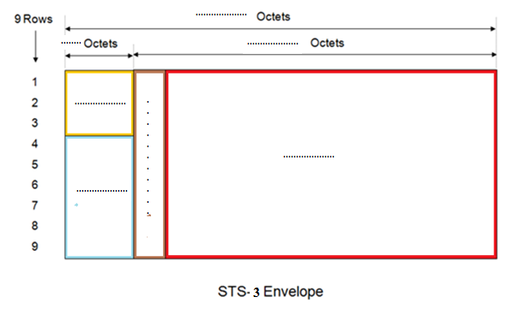

Topic 6 - Asynchronous Transfer Mode (ATM)
Q6- Choose the correct answers : (2.5 Grades)
1. The ATM Layer converts application data into ATM data units in order to provide support for
user applications.
(a) Physical Layer (b) ATM Layer (c) AAL Layer
2. The ATM Layer is responsible for the simultaneous sharing of virtual circuits over a physical
link (cell multiplexing)
(a) Physical Layer (b) ATM Layer (c) AAL Layer
3. When a virtual circuit is established, both the transport layer in the host machine and the network must agree on a ................ defining the service.
(a) Traffic contract (b) Traffic shaping (c) Traffic policing
4. ............. the number of cells/sec that are delivered to the wrong destination because of an undetected error in the header.
(a) Cell Miss-insertion Rate (CMR) (b) Cell Loss Ratio (c) Cell Error Rato (CER)
5. The .............is split into A segmentation and Reassembly sublayer (SAR) and a convergence sublayer
(a) Physical Layer (b) ATM Layer (c) AAL Layer

Q7 - Fill name of layers, sub-layers and planes for the ATM Reference Model (2.5 Grades)

