Question Number: 1 (2 Marks)
Put true ( √ ) or false ( × )in front of each of the following sentences and correct the wrong sentences when found:
- In wet preparation of yeast we are able to examine the organism under 100 x.
- Some Yeasts are single-cell eukaryotic organism that classified as members of fungi.
- Schizosacccharomyces species are known to produce red – orange pigments.
- C. albicans is known to produce basidiospres when cultivated on Corn meal Tween 80 Agar.

Question Number: 2 (2 Marks)
Fill the following blanks with suitable words:
- .................................. and .................................. belong to Ascomycota, while .................................. and .................................. belong to Basidiomycots
- Yeast Cell wall is composed of .................................. , .................................. and ..................................
- An indicator used in fermentation test is…………………………..
- General Media used for yeast cultivation is……………………………..
Question Number: 3 (2 Marks)
Complete the missing parts in the following structure :
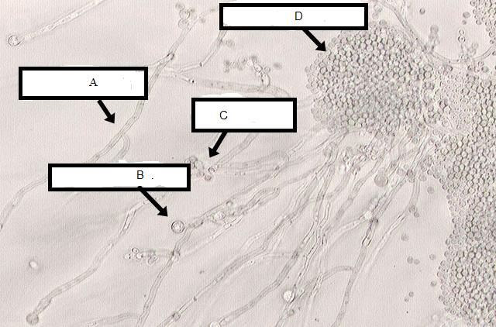

(A) .................................... (B) ....................................

(C) ................................... (D) ....................................

