**Math 244-Syllabus**

**Text book: Elementary Linear Algebra with Supplemental Applications, 11th Edition By Howard Anton and Chris Rorres**

**Chapter 1**

**1.1 Introduction to Systems of Linear Equations**

**1.2** **Gaussian Elimination**

**1.3** **Matrices and Matrix Operations**

**1.4** **Inverses and Algebraic Properties of Matrices (Proofs of Theorems 1.4.4, 1.4.6, and 1.4.9 are included)**

**1.5** **Elementary Matrices and a Method for Finding** 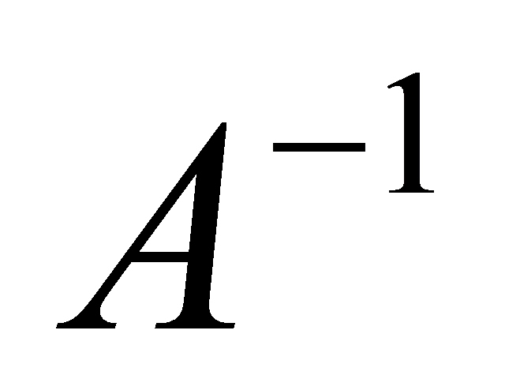

**1.6 More on Linear Systems and Invertible Matrices**

**1.7** **Diagonal, Triangular and Symmetric Matrices**

**Chapter 2**

**2.1** **Determinants by Cofactor Expansion**

**2.2 Evaluating Determinants by Row Reduction**

**2.3 Properties of the Determinants and Cramer's Rule**

**Chapter 3**

**3.1** **Vectors in 2-Space, 3-Space and n-Space (From Definition1, Page 124).**

**3.2 Norm, Dot Product and Distance in 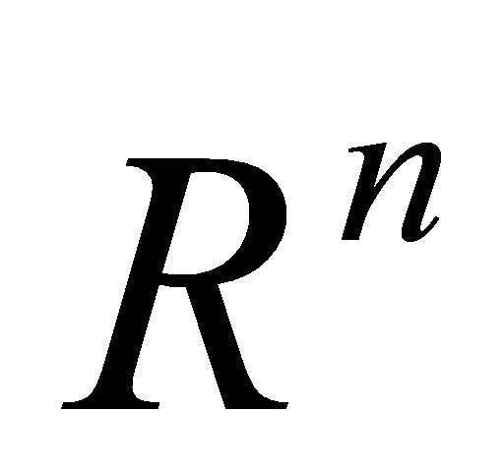(The proof of Theorem 3.2.6 and Theorem 3.2.7 is included). Example 6 on page 134 is NOT included.**

**3.3 Orthogonality (Definition1, Example1 (a), Theorem 3.3.3, Example 6)**

**Chapter 4**

**4.1** **Real Vector Spaces (Exercise 11 is solved in the lecture)**

**4.2 Subspaces (All except Example 12, the proof of Theorem 4.2.4 is included)**

**4.3 Linear Independence (Proof of Theorem 4.3.3 is included)**

**4.4** **Coordinates and Basis (From Definition 1)**

**4.5 Dimension (Exercise 7 (d) is solved in the lecture)**

**4.7 Row Space, Column Space and Null space**

**4.8** **Rank, Nullity and the Fundamental Matrix Spaces (The proof of theorem 4.8.7 is included). (The concept of orthogonal complement is NOT included).**

**4.9 Matrix Transformations from**  **to 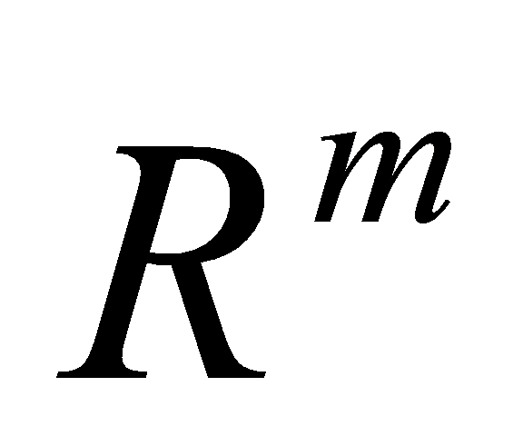(Expansion and Compressions, Shears and Orthogonal projections on lines through the origin are NOT included)**

**4.10 Properties of Matrix Transformations**

**Chapter 5**

**5.1** **Eigenvalues and Eigenvectors**