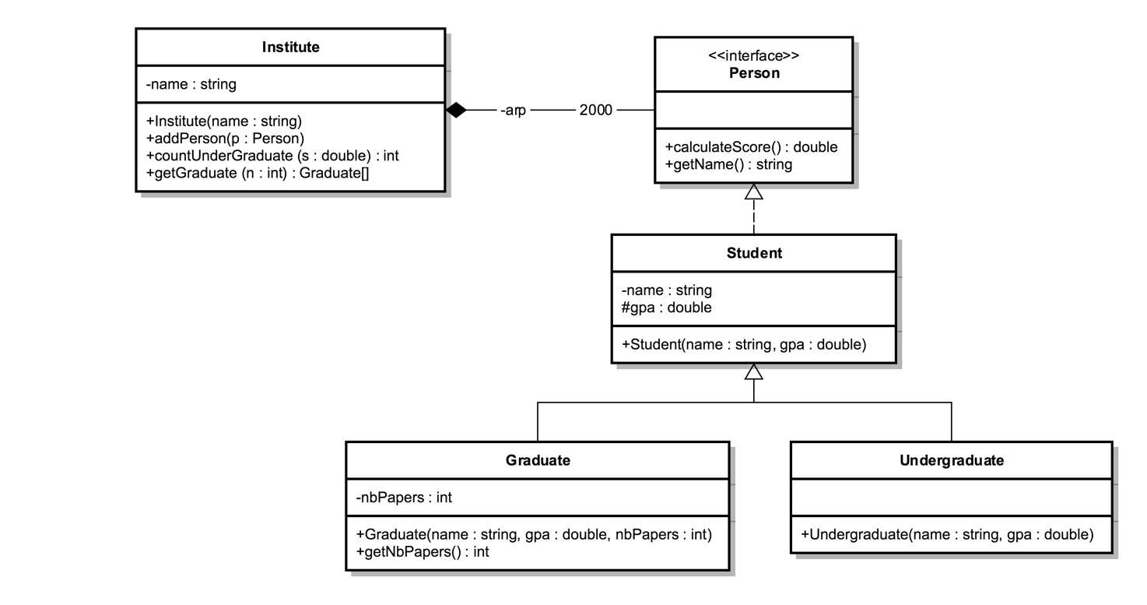

Interface Person:
- METHODS:
- calculateScore (): calculated as:
- for Graduate : Score = nbPapers * gpa
- for UnderGraduate: Score = gpa * 3 + 5

- getName (): returns the name of the student.

Student class
- METHODS:
- Student (name: String, gpa : double): constructor.

Graduate class
- METHODS:
- Graduate (name: String, gpa : double, nbPpapers : int): constructor.
- getNbPapers(): getter for attribute nbPapers.

UnderGraduate class
- METHODS:
- UnderGraduate (name: String, gpa : double): constructor.

Institute class
- METHODS:
- Institute(name: String): constructor.
- addPerson(p: Person): add a person to the institute.
- countUnderGraduate (s : double): count the number of UnderGraduate in the institute with score grater or equal to s.
- getGraduate (n : int): this method will return an array containing all the Graduate with number of papers greater than n.

QUESTION: Translate into Java code all the classes

