***[BCH 322]***

***The effect of pH on the rate of an enzyme catalyzed reaction***

***Method:***

1. Prepare 16 tubes labeled as follows (note: there is a blank for each pH)
   1. Blank: (B3, B4, B4.5, B5, B5.5, B6, B7, B8, B9)
   2. Test: (T3, T4, T4.5, T5, T5.5, T6, T7, T8, T9)
2. 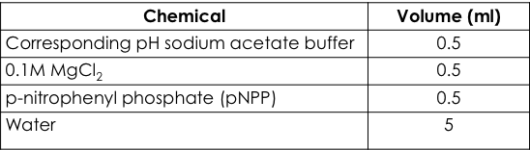To each of these tubes add
3. Place the tubes in a test tube rack situated in 37oC water bath and let stand for 5 min.
4. Start the reaction by adding 0.5 ml enzyme and stop it by adding 0.5 ml KOH as in the following table:

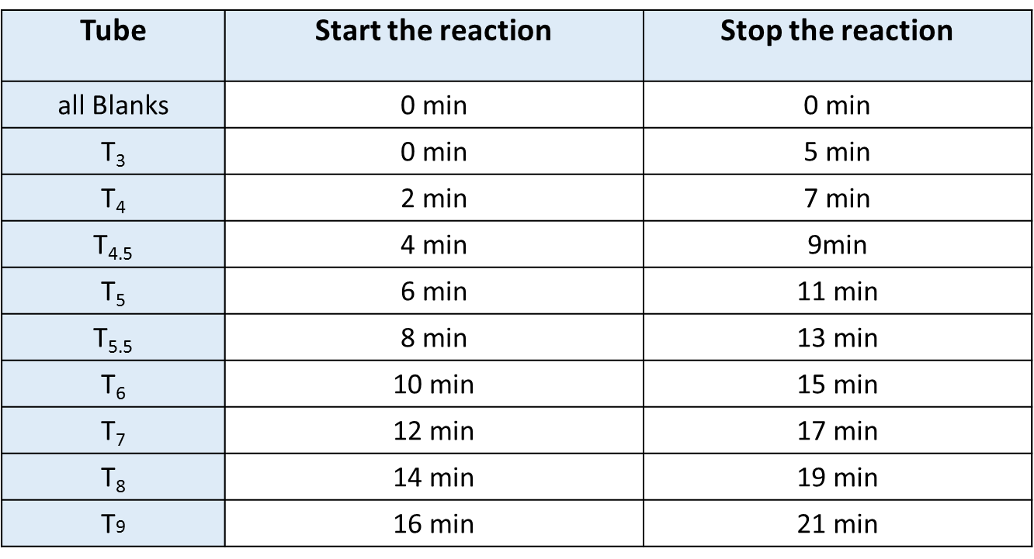



1. After all the reactions have been terminated, determine the absorbance at 405 nm for each sample.

**Results:**

