LAB Exam 2.

prod.h

#if ! defined PROD
#define PROD

/* struct Product has the following members:
- serial as integer
- name as string of maximum length of 24 letters
- price as floating point number */
typedef struct Product Product;

/* function read_product reads product’s information from
the Keyboard and fills it in the parameter p */
void read_product(Product* p);

/* function print_product prints the information of
the product p to the screen */
void print_product(Product p);

/* function discounted_copy takes a Product parameter p and
returns a pointer to a new copy of p after applying a 10%
discount on the price */
Product* discounted_copy(Product p);

/* function prod_gt_999 takes an array of products parr of size
s and returns a new array contains discounted copies of
products with prices greater than 999.99, of size res_s */
Product* prod_gt_999(Product* parr, int s, int* res_s);

/* function save_to_file stores the size of array parr in the file
fn, then stores all products of parr in the file and returns
1 if succeeds, and 0 otherwise */
int save_to_file(char* fn, Product* parr, int size);

#endif

prod.c
#include <stdio.h>
#include <stdlib.h>
#include "prod.h"

struct Product{
int serial;
char name[25];
float price;
};

void read_product(Product* p){
char c;
printf("Enter the serial number: ");
scanf("%d", &(p->serial));
printf("Enter the name: ");
while ((c=getchar())=='\n');
ungetc(c, stdin);
gets(p->name);
printf("Enter the price: ");
scanf("%f", &(p->price));
}

void print_product(Product p){
printf("Serial number: %d\n", p.serial);
printf("Name: %s\n", p.name);
printf("Price: %.2f\n", p.price);
printf("--------------\n");
}

Product* discounted_copy(Product p){
Product* result;
result = (Product*)malloc(sizeof(Product));
result->serial = p.serial;
sprintf(result->name, "%s", p.name);
result->price = p.price * 0.9;
return result;
}

Product* prod_gt_999(Product* parr, int s, int* res_s){
int i, j;
Product* result;
*res_s = 0;
for (i=0; i< s; i++)
if (parr[i].price > 999.99) (*res_s)++;
result = (Product*)malloc((*res_s)*sizeof(Product));
for(i=0,j=0; i<s; i++)
if (parr[i].price > 999.99)
result[j++] = *(discounted_copy(parr[i]));
return result;
}

int save_to_file(char* fn, Product* parr, int size){
int i;
FILE* fp = fopen(fn, "w");
fwrite(&size, sizeof(int), 1, fp);
for (i=0; i<size; i++)
fwrite(&(parr[i]), sizeof(Product), 1, fp);
fclose(fp);
return size;
}

int main(void) {
int num, num_999, i;
Product *prod_arr, *prod_999;

/* ask the user to enter number of products num */
printf("Enter number of products:");
scanf("%d", &num);

/* allocate enough memory for array prod_arr to store num products */
prod_arr = (Product*)malloc(num*sizeof(Product));

/* read the information of the num products from the keyboard */
for (i=0; i < num; i++)
read_product(&(prod_arr[i]));

/* store products with price > 999.99 in the array prod_999
of size num_999 */
prod_999 = prod_gt_999(prod_arr, num, &num_999);

/* print the information of all products in prod_999 to the screen */
printf("\nProducts with price more than 999.99\n");
printf("============================================\n");
for (i=0; i < num_999; i++)
print_product(prod_999[i]);

/* store the number of products in prod_999 and their information in
the file "prod-999.dat"*/
save_to_file("prod-999.dat", prod_999, num_999);

return 0;
}

data.txt
4
22
Toshiba TV
5700
17
iPod G6
890
25
LG Freezer
4200
29
Samsung Vacuum Cleaner
397

*=+*+*+*+*+*+*+*+*+*+**+*+*+*+*+*+*+**+*+*++++**+*+***********+*+*+

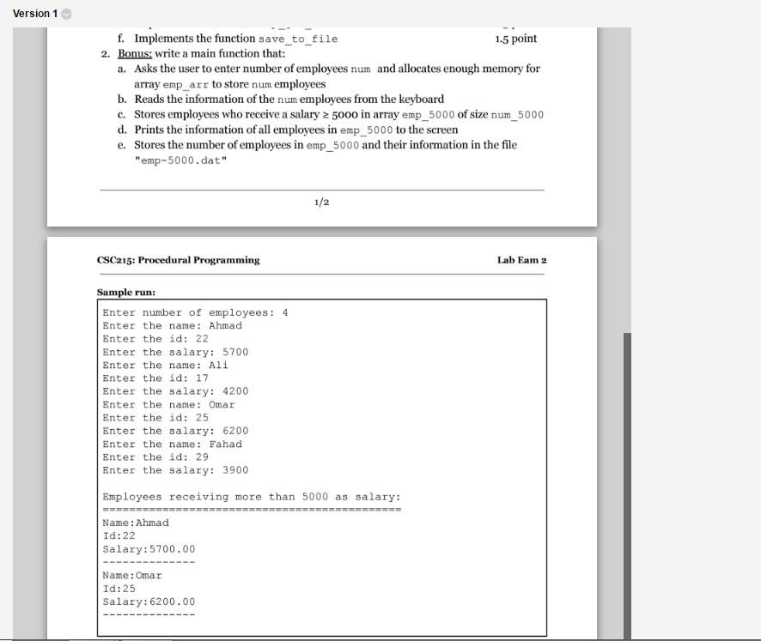

// emp.h
#if ! defined EMP
#define EMP

typedef struct Employee Employee;

void read_employee(Employee* e);

void print_employee(Employee e);

Employee* copy_employee(Employee e);

Employee* emp_gte_5000(Employee* earr, int size, int* res_size);

int save_to_file(char* fn, Employee* earr, int size);

#endif

#include <stdio.h>
#include <stdlib.h>
#include "emp.h"

struct Employee{
char name[25];
int id;
float salary;
};

void read_employee(Employee* e){
char c;
printf("Enter the name: ");
while ((c=getchar())=='\n');
ungetc(c, stdin);
gets(e->name);
printf("Enter the id: ");
scanf("%d", &(e->id));
printf("Enter the salary: ");
scanf("%f", &(e->salary));
}

void print_employee(Employee e){
printf("Name:%s\n", e.name);
printf("Id:%d\n", e.id);
printf("Salary:%.2f\n", e.salary);
printf("--------------\n");
}

Employee* copy_employee(Employee e){
Employee* result;
result = (Employee*)malloc(sizeof(Employee));
*result = e;
/* you can also do this:
sprintf(result->name, "%s", e.name);
result->id = e.id;
result->salary = e.salary; */
return result;
}

Employee* emp_sal_gte_5000(Employee* earr, int size, int* res_size){
int i, j;
Employee* result;
*res_size = 0;
for (i=0; i< size; i++)
if (earr[i].salary > 5000) (*res_size)++;
result = (Employee*)malloc((*res_size)*sizeof(Employee));
for(i=0,j=0; i<size; i++)
if (earr[i].salary >= 5000)
result[j++] = *(copy_employee(earr[i]));
return result;
}

int save_to_file(char* fn, Employee* earr, int size){
int i;
FILE* fp = fopen(fn, "w");
fwrite(&size, sizeof(int), 1, fp);
for (i=0; i<size; i++)
fwrite(&(earr[i]), sizeof(Employee), 1, fp);
fclose(fp);
return size;
}

int main(void) {
int num, num_5000, i;
Employee *emp_arr, *emp_5000;

/* ask the user to enter number of employees num */
printf("Enter number of employees:");
scanf("%d", &num);

/* allocate enough memory for array emp_arr to store num employees */
emp_arr = (Employee*)malloc(num*sizeof(Employee));

/* read the information of the num employees from the keyboard */
for (i=0; i < num; i++)
read_employee(&(emp_arr[i]));

/* store employees who receive a salary = 5000 in the array emp_5000
of size num_5000 */
emp_5000 = emp_sal_gte_5000(emp_arr, num, &num_5000);

/* print the information of all employees in emp_5000 to the screen */
printf("\nEmployees receiving more than 5000 as salary\n");
printf("============================================\n");
for (i=0; i < num_5000; i++)
print_employee(emp_5000[i]);

/* store the number of employees in emp_5000 and their information in
the file "emp-5000.dat"*/
save_to_file("emp-5000.dat", emp_5000, num_5000);

return 0;
}

// data.txt
4
Ahmad
22
5700
Ali
17
4500
Omar
25
6200
Fahad
29
3900

