Sedimentary Rocks under microscope
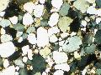 | Sandstone  This sandstone is made of quite well rounded grains of quartz, cemented together by calcium carbonate. Cambrian, NW Scotland.  Field of view 3.5 mm, polarising filters.

Sandstone (with mica)
A fairly fine-grained sandstone made of rather angular grains of quartz and feldspar (feldspar looks more cloudy). Narrow flakes of mica, seen edge-on, and slightly crumpled, lie on bedding planes. Precambrian (Torridonian), Raasay, Inner Hebrides, Scotland. Field of view 3.5 mm.

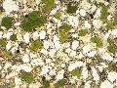 | Greensand  The green colour that this Cretaceous sandstone has in hand specimen comes from the rounded grains of the mineral glauconite, seen here among quartz grains in a matrix of clay and calcium carbonate. Field of view 3.5 mm.

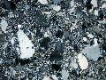 | Greywacke (impure sandstone)  Greywackes are impure sandstones in which the grains are commonly made of feldspar and rock fragments as well as quartz. Notice that the grains have a wide range of sizes, and that some are rounded, some not. Field of view 5 mm, polarising filters.

Limestone (with fossil fragments)
This is a fairly typical limestone deposited in shallow water. A good proportion of the particles are tiny shells and worm tubes, and much of the rest is very small particles of calcium carbonate. Where there was empty space in the sediment, such as inside the worm tube on the right of the picture, larger crystals of calcite have grown. Field of view 3.5 mm, polarising filters.

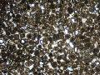 | Limestone (oolitic)  Oolitic limestone is made up largely of sand-sized, rounded pellets of calcium carbonate, which are formed in warm shallow water where carbonate sediment is moved about by currents. Isle of Skye, Scotland. Field of view 4.5 mm, polarising filters.

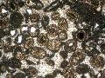 | Limestone (oolitic)  Oolitic limestone is made up largely of sand-sized, rounded pellets of calcium carbonate. In this closer view we can see that some of the pellets have grown by adding layers of calcium carbonate onto a tiny sedimentary grain of quartz. Isle of Skye, Scotland. Field of view 3 mm.

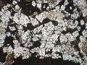 | Limestone (dolomitic)  In this limestone, diamond-shaped crystals of dolomite (calcium magnesium carbonate) have grown after deposition, while the sediment was being changed into rock. They replace the fine calcium carbonate mud (dark material in the photo) that makes up the rest of the rock. Field of view 3.5 mm.

Coal
Coal is mostly opaque under the microscope, as you might expect. The red-black material (vitrinite) in the thin section is the part of the coal that appears shiny black in hand sample, and is made from compressed wood tissue. The loop-shaped orange-yellow objects are the flattened large spores of plants. Field of view 3 mm.

