Metamorphic Rock Identification

Metamorphic Rocks
Metamorphic rocks are rocks that have undergone a change from their original form due to changes in temperature, pressure or chemical alteration. The classification of metamorphic rocks is based on the minerals that are present and the temperature and pressure at which these minerals form. Determination of this information is not easily accomplished in this lab. Therefore, a simplified system is used based on texture and composition.

Texture
Texture is divided into two groups. Foliated textures show a distinct planar character. This means that the minerals in the rock are all aligned with each other. This planar character can be flat like a piece of slate or folded. Non-foliated textures have minerals that are not aligned. Essentially, the minerals are randomly oriented.

Foliation
Foliated textures show four types of foliation. Slaty cleavage is composed of platy minerals that are too small to see. Typically, these rocks split along parallel, planar surfaces. Phyllitic foliation is composed of platy minerals that are slightly larger than those found in slaty cleavage, but generally are still too small to see with the unaided eye. The larger size gives the foliation a slighly shiny appearance. Schistose foliation is composed of larger minerals which are visible to the unaided eye. Platy minerals tend to dominate. Gneissic banding is the easiest of the foliations to recognize. It is composed of alternating bands of dark and light minerals.

Non-Foliation
Non-foliated textures are identified by their lack of planar character. Further identification of non-foliated rocks is dependent on the composition of the minerals or components in the rock. Anthracite coal is similar to bituminous coal. Both are black in color , and is composed of carbon. Anthracite coal is generally shiny in appearance and breaks with a conchoidal fracture (broken glass also shows this type of fracture). Metaconglomerate is composed of pebbles and gravel that have been flattened due to directed pressure. Quartzite is composed of quartz sand grains. Quartz has a hardness of 7, which makes it difficult to scratch. Marble is composed of calcite and will readily react to a small drop of HCl.
Metamorphic Rock Identification Chart
TEXTURE | FOLIATION | COMPOSITION | TYPE | PARENT ROCK | ROCK NAME
Foliated | slaty | mica | Regional | Mudstone | Slate
 | phyllitic | quartz, mica, chlorite | Regional | Mudstone | Phyllite
 | schistose | mica, quartz | Regional | Slate | Schist
 | schistose | amphibole, plagioclase | Regional | Basalt or Gabbro | Amphibolite or  hornfels
 | gneissic banding | feldspar, mica, quartz | Regional | Schist | Gneiss
Non-Foliated |  | carbon | Contact or Regional | Bituminous Coal | Anthracite Coal
 |  | quartz, rock fragments | Contact or Regional | Conglomerate | Metaconglomerate
 |  | calcite | Contact or Regional | Limestone | Marble
 |  | quartz | Contact or Regional | Sandstone | Quartzite

METAMORPHIC ROCK
TEXTURES
Foliated Texture

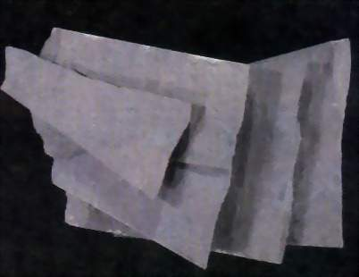
The mineral constituents of foliated metamorphic rocks are oriented in a parallel or suhparallel arrangement. Foliated metamorphic rocks are generally associated with regional metamorphism. Four kinds of foliated textures arc recognized. In order of increasing metamorphic grade, these are slaty, phyllitic, schistose and gneissic.
Slaty Texture - This texture is caused by the parallel orientation of microscopic grains. The name for the rock with this texture is slate , and the rock is characterized by a tendency to separate along parallel planes. This feature is a property known as slaty cleavage. (Slaty cleavage or rock cleavage is not to be confused with cleavage in a mineral, which is related to the internal atomic structure of the mineral.)

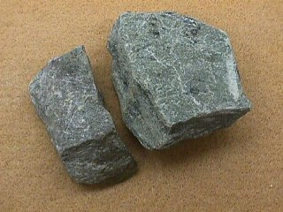
Phyllitic Texture - This texture is formed by the parallel arrangement of platy minerals, usually micas, that are barely macroscopic (visible to the naked eye). The parallelism is often silky, or crenulated. The predominance of micaceous minerals imparts a sheen to the hand specimens. A rock with a phyllitic texture is called a phyllite.
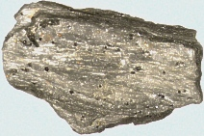
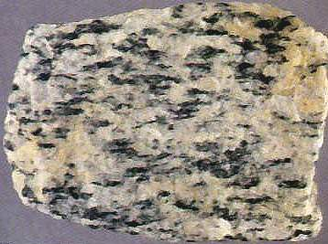
Schistose Texture This is a foliated texture resulting from the suhparallel to parallel orientation of platy minerals such as chlorite or micas. Other common minerals present are quartz and amphiholes. A schistose texture lies between the parallel platy appearance of phyllite and the distinct banding of gneissic texture. The average grain size of the minerals is generally smaller than in a gneiss. A rock with schistose texture is called a schist
Gneissic Texture This is a coarsely foliated texture in which the minerals have been segregated into discontinuous hands, each of which is dominated by one or two minerals. These bands range in thickness from 1 mm to several centimeters. The individual mineral grains are macroscopic and impart a striped appearance to a hand specimen. Light-colored bands commonly contain quartz and feldspar. and the dark hands are commonly composed of hornblende and hiotite. Accessory minerals are common and are useful in applying specific names to these rocks. A rock with a gneissic texture is called a gneiss.

Nonfoliated Texture

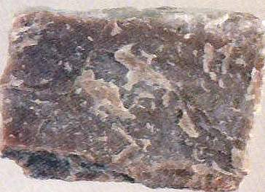
Metamorphic rocks with no visible preferred orientation of mineral grains have a nonfoliated texture. Nonfoliated rocks commonly contain equidimensional grains of a single mineral such as quartz, calcite, or dolomite. Examples of such rocks are
1- quartzite , formed from a quartz sandstone Quartzite and metamorphosed conglomerate can be distinguished from their sedimentary equivalents by the fact that they break across the quartz grains, not around them..
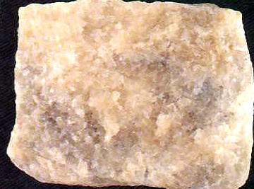
2- marble , formed from a limestone or dolomite. Marble has a crystalline appearance and generally has larger mineral grains than its sedimentary equivalent

3- Hornfels formed from basalt A fine-grained (dense-textured), nonfoliated rock usually of contact metamorphic origin is
4- anthracite coal The metamorphic equivalent of bituminous coal

