Sedimentary Rock Identification

Sedimentary Rocks
Sedimentary rocks are rocks composed of sediment. Sediment is deposited in a number of environments of deposition, by both moving air and moving water. Sedimentary rock identification is primarily based on composition. Texture will still be used but in a different sense than for igneous rocks.

Textureof sedimentary rocks in this lab will be taken to indicate origin or type of sediment found in the rock. Three types of "texture" will be used - clastic, chemical, and biologic.

Clastic Rockssedimentary rocks contain clasts. These are fragments or pieces of rock or minerals. The composition of clastic sedimentary rocks is divided into three types - clay/silt, sand and gravel. Clay and silt are less than 1/16 mm. These are not visible to the unaided eye. Sand is clasts between 1/16 and 2 mm in size, and gravel is greater than 2 mm.

Chemical Rockssedimentary rocks are identified by identifying the mineral from which they are composed. In this lab there are four minerals that need to be identified - quartz, halite, gypsum and calcite. Quartz has a hardness of 7 and is very difficult to scratch, even with a good quality knife blade. Gypsum is relatively soft (Hardness =2) and can be scratched easily with a fingernail. Halite is common table salt and is most easily identified by taste. However, this is not a sensible practice in a large lab with many different people handling the samples. Halite has a hardness of 2.5 and cannot be scratched by a fingernail (unpolished fingernail). Calcite readily reacts with a small drop of HCl.

Biologic Rocks sedimentary rocks are which form as the result of the accumulation of organic material or biologic activity. Coal is usually obvious to most students even though few people seem to have ever actually examined it up close. The dark brown to black color is the most obvious charateristic. Coquina and limestone are both composed of calcite . Coquina is composed almost entirely of shell or fossil fragments. Limestone may or may not contain fossils fragments. Both will react to HCl. Limestone containing fossils is referred to as fossiliferous limestone.

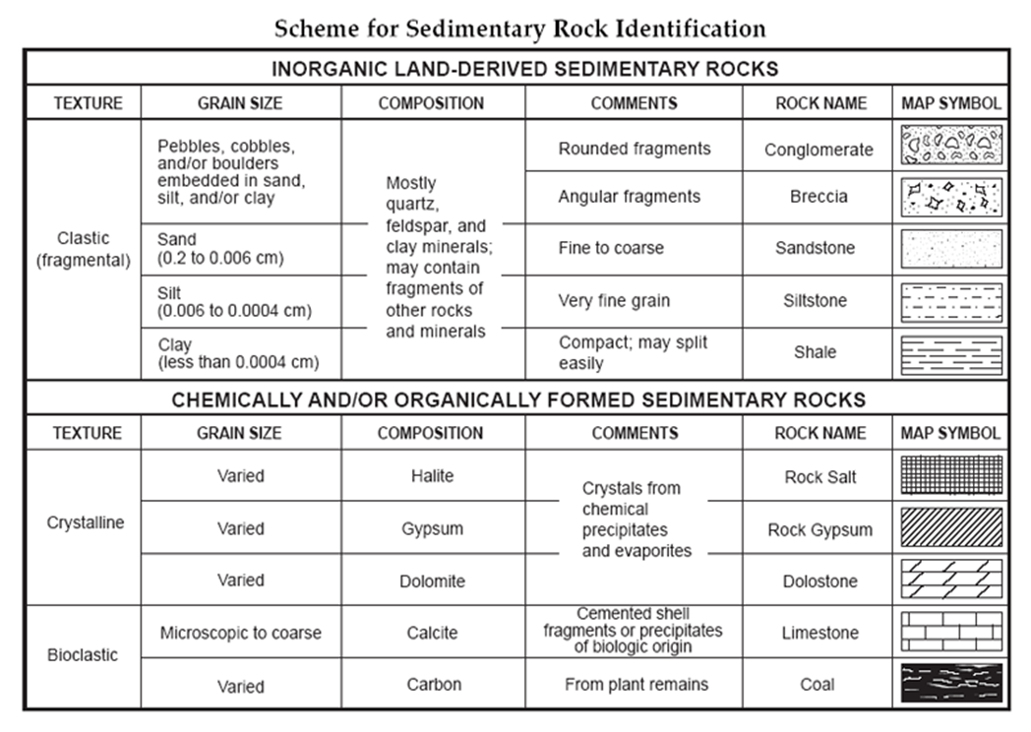

Sedimentary rocks description chart

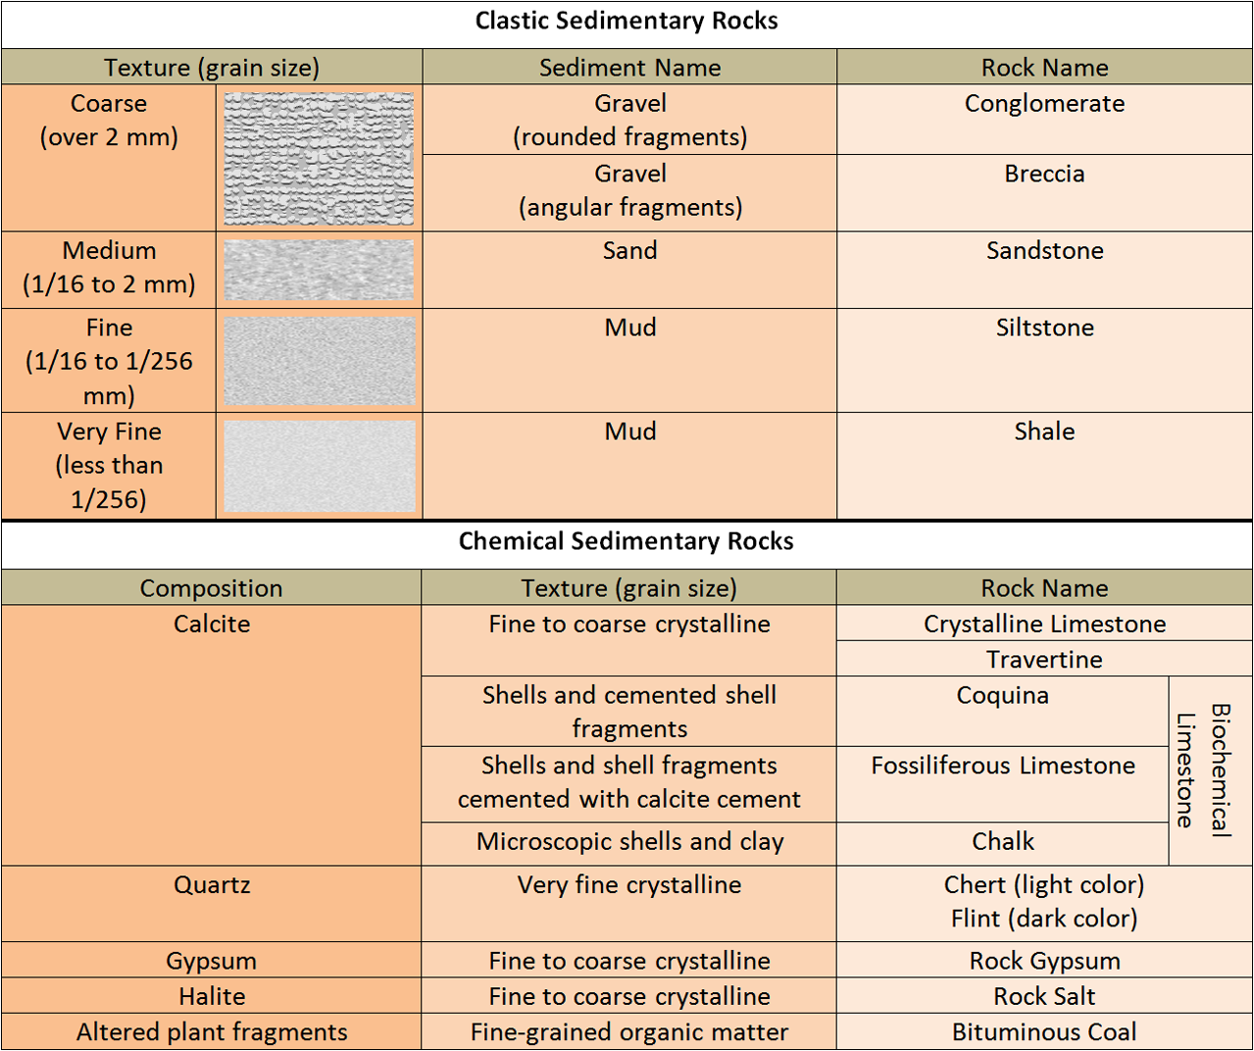

Texture or origin | Grain size | Mineral Composition | Description | Rock name | Notice ( color- fossils - ,,,)

