- Write a program that:
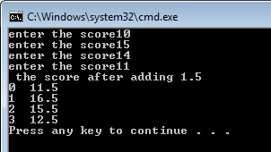
- declares a 4 elements array. Each array element should contain a student score that is read from the user. After completely filling the array, the program should then add the number 1.5 to each array element and print the result.

- calculates the sum of the even elements of the array below.
s[]={ 1,2,4,5,6,2,9,4,10,1};

- assume you have two arrays
array1 [5] = {1, 2, 3, 4, 5},
array2 [5] = {10, 9, 8, 7, 6}
  - Multiply two arrays array 1 and array2, and store the result in a third array3 .
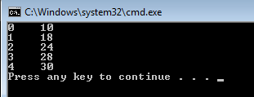

  - Display the values in array3 in reverse order.
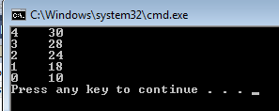

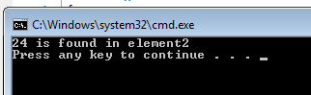
  - Find the value 24 in array3 and show the index of the matching array element.

