- What is the output of the following C program (assume num =1235 )?
#include <stdio.h>

int main()
{
int num, reverse = 0;

/* Input a number from user */
printf("Enter any number to find reverse: ");
scanf("%d", &num);

/* Repeat the till 'num' becomes 0 */
while(num != 0)
{
reverse = (reverse * 10) + (num % 10);

/* Remove last digit from 'num' */
num /= 10;
}

printf("Reverse = %d", reverse);

return 0;
}

- Rewrite the following C code (for statement) using while statement.
#include <stdio.h>

Int main()
{
int i, n, sum=0;

/* Input range to find sum of odd numbers */
printf("Enter upper limit: ");
scanf("%d", &n);

/* Find the sum of all odd number */
for(i=1; i<=n; i+=2)
{
sum += i;
}

printf("Sum of odd numbers = %d", sum);

return 0;
}
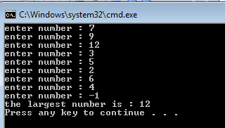
- Write a C program to determine the largest number for unknown set of positive numbers.

- Prompts the user to enter the number of lines to draw a triangle of stars upside down.
