- Perform the following tasks.
- Define a base class called Person, which has the following members:

Private Data Items:
Name, SSN
Public Functions:
set_Personal_info() // set for the above info (from the user).
print_info() // prints all the info for the class.
Person() // constructor print a message "person constructor"
~Person() // destructor print a message "person destructor"

- Now define a class called Student, which is publicly derived from Person. It should have the following public members:

Protected Data Items:
Major // engineering, business, history, etc.
Hours // how many Hours student has learned
GPA // Grade Point Average
Public Functions:
set_Student_info() // a function that sets for student info from user
print_Student_info() // print the stored information
Student() // constructor print a message "student constructor"
~Student() // destructor print a message "student destructor"
- Write a short main() program which instantiates as an object of the class Student yourself (the object name will be your name ).
- Supply all the information through the set_Student_info() and set_Personal_info() functions called by the user, and print the data out using the function print
Turn in the .CPP file and the screen output.
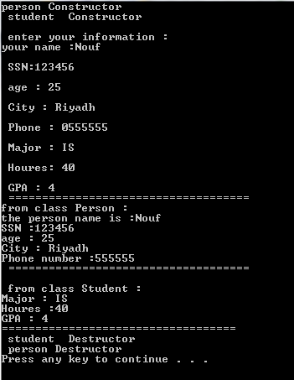

- On the same Question above change the access ID for the inheritance to private .What are the changes you need to do in the class to still perform the same as Q1
Turn in the .CPP file and the screen output.

