a

- Perform the following tasks.
- Define a base class called Person, which has the following members:

Private Data Items:
Name, SSN , age, City, Phone
Public Functions:
Person() // constructor print a message "person constructor"
~Person() // destructor print a message "person destructor"
set_info() // set for the above info (user input in the function).
print_info() // prints all the info for this class.

- Now define a class called Student, which is publicly derived from Person. It should have the following public members:

private Data Items:
Major // engineering, business, history, etc.
Hours // how many Hours student has learned
GPA // Grade Point Average
Public Functions:
set_info() // a function that sets for student info (user input in the function).
print_info() // print the stored information
Student() // constructor print a message "student constructor"
~Student() // destructor print a message "student destructor"
- Write a short main() program which define an object of the class Student, the object name will be your name.
- Supply all the information through the set_info() functions, both functions are called in main.
- Print the data out using the two print functions.
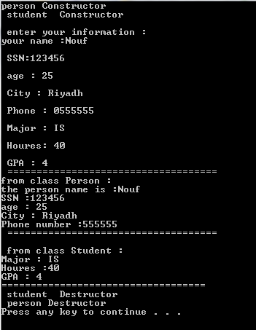

- On the same Question above change the access ID for the inheritance to private .What are the changes you need to do in the class to still perform the same as Q1
Turn in the .CPP file and the screen output.

