- Identify and correct the errors in each of the following program. (Note: There may be more than one error per statement.)

#include <studio.h>
Int main()(
int x,y
scanf( "&d, &d", %x %y);
printf( "The sum of %d and %d is %d /n", x, y )
)

- Write a program that prints the following shapes with asterisks.
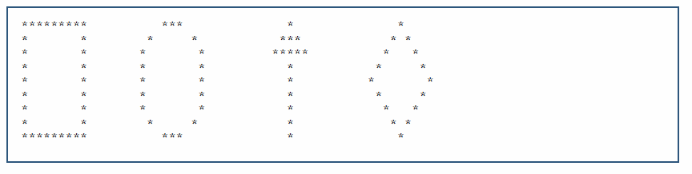

- Write a program that asks the user to enter the total time elapsed, in seconds, since an event and converts the time to hours, minutes and seconds. The time should be displayed as hours:minutes:seconds. [Hint: Use the remainder operator]

