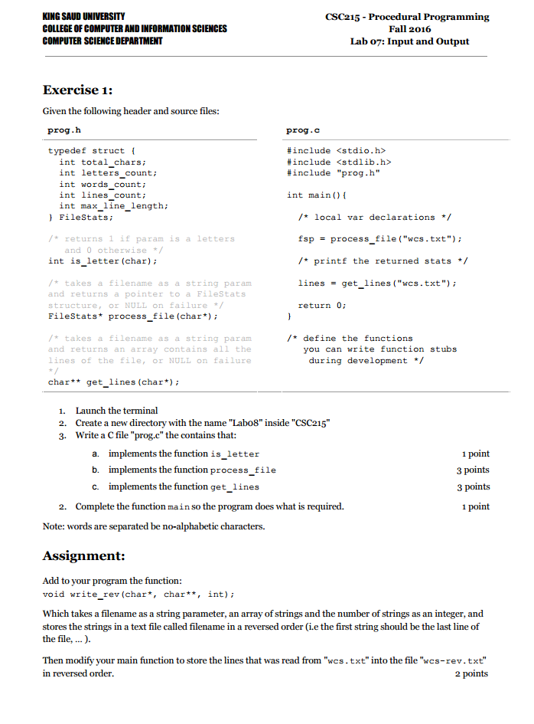

*************prog.h*******************
typedef struct {
int total_chars;
int letters_count;
int words_count;
int lines_count;
int max_line_length;
} FileStats;

int is_letter(char);

FileStats* process_file(char*);

char** get_lines(char*);

void write_rev(char*, char**, int);

**************prog.c*****************

#include <stdio.h>
#include <stdlib.h>
#include "prog.h"

int main(){
FileStats *fsp;
char** lines;
fsp = process_file("wcs.txt");
if (fsp){
printf("File size = %d\n", fsp->total_chars);
printf("Number of letters = %d\n", fsp->letters_count);
printf("Number of Words = %d\n", fsp->words_count);
printf("Number of lines = %d\n", fsp->lines_count);
printf("Length of longest line = %d\n", fsp->max_line_length);
}

lines = get_lines("wcs.txt");

write_rev("wcs-rev.txt", lines, fsp->lines_count);

return 0;
}

int is_letter(char c){
return (c>='A' && c<='Z') || (c>='a' && c<='z');
}

FileStats* process_file(char* fn){
FileStats* fs;
FILE* fp;
char c;
int inword = 0;
int line_length = 0;

if (!(fs = (FileStats*)calloc(1, sizeof(FileStats)))) return NULL;

if (!(fp = fopen(fn, "r"))) return NULL;

do {
c=getc(fp);
fs->total_chars++;

if (is_letter(c)){
fs->letters_count++;
inword = 1;
}
else {
if (inword) fs->words_count++;
inword = 0;
}

if (c == '\n' || c == EOF){
fs->lines_count++;
if (fs->max_line_length < line_length)
fs->max_line_length = line_length;
line_length = 0;
}
else line_length++;

} while (c != EOF);
fclose(fp);
return fs;
}

char** get_lines(char* fn){
char c;
int i;
char **lines, *p;

FileStats* fs;
FILE* fp;

if (!(fs = process_file(fn))) return NULL;

lines = (char**)calloc(fs->lines_count, sizeof(char*));
for (i=0; i < fs->lines_count; i++)
lines[i] = (char*)calloc(fs->max_line_length+1, 1);

if (!(fp = fopen(fn, "r"))) return NULL;

i = 0;
p = lines[0];
do {
c = getc(fp);
if (c == '\n' || c == EOF)
p = lines[++i];
else
*p++ = c;
} while (c != EOF);
return lines;
}

void write_rev(char* fn, char** lines, int count){
int i;
FILE* fp = fopen(fn, "w");
for (i=count-1; i >= 0; i--){
fputs(lines[i], fp);
if (i) fprintf(fp, "\n");
}
fclose(fp);
}

