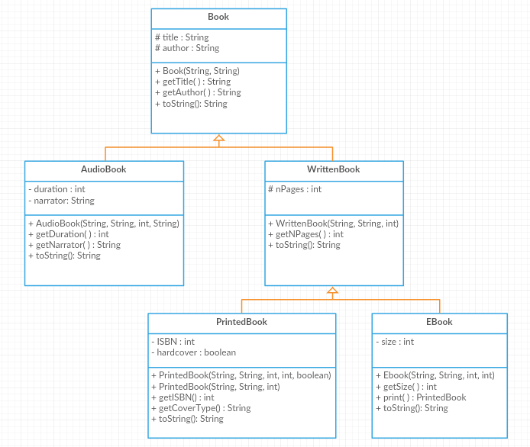

Book class:
Attributes:
- title: the title of the book
- author: the author of the book
Methods:
- Book(title: String, author: int): constructor
- getTitle(): this method returns the title of the book
- getAuthor(): this method returns the author of the book
- toString(): returns the object’s info in this format: ‘Title: title, Author: author’

AudioBook class:
Attributes:
- duration: the length of the audio file in minutes
- narrator: the name of the person reading the book

Methods:
- AudioBook(title: String, author: String, duration: int, narrator: String): constructor
- getDuration(): this method returns the duration of the audio book
- getNarrator(): this method returns the name of the narrator
- toString(): returns the object’s info in this format: ‘Title: title, Author: author, Format: Audio, Duration: duration, Narrator: narrator’

WrittenBook class:
Attributes:
- nPages: the number of pages of the book
Methods:
- WrittenBook(title: String, author: String, nPages: int): constructor
- getNPages (): this method returns the number of pages of the book
- toString(): returns the object’s info in this format: ‘Title: title, Author: author, Format: Written, number of pages: nPages’

PrintedBook class:
Attributes:
- ISBN: the International Standard Book Number of the book
- hardcover: true if the book is hardcover, false otherwise
Methods:
- PrintedBook(title: String, author: String, nPages: int, ISBN: int, hardcover: boolean): constructor
- PrintedBook(title: String, author:String, nPages: int): constructor that initializes ISBN to 0 and hardcover to false
- getISBN(): this method returns the ISBN of the book
- getCoverType(): returns a string specifying if the book is hardcover or paperback
- toString(): returns the object’s info in this format: ‘Title: title, Author: author, Format: Written, number of pages: nPages, Printed, ISBN: ISBN, hardcover/paperback’

EBook class:
Attributes:
- size: the size of the ebook in MBs
Methods:
- EBook(title: String, author: String, nPages: int, size: int): constructor
- getSize(): this method returns the size of the ebook
- print(): this method returns the current Ebook as an object of type PrintedBook
- toString(): returns the object’s info in this format: ‘Title: title, Author: author, Format: Written, number of pages: nPages, Ebook, size: sizeMB’

Exercise: Translate into Java-code the previous classes.

