Microbiology 140 MIC (Practical)
List of Topics | No. Of Weeks
Introduction To the Basic Skills of Microbiology and Biohazards, Biosafety Precaution. | 1
Sterilization Techniques | 2
Microbiology Culture Media: Types, Purpose, Examples. | 3
Isolation of Bacteria From Different Sourses ( ex: skin ,air, plants stem and leaf, tap water). | 4
Serial Diluation Method: Identificaion, Purpose of Use + Isolation of Bacteria and Fungi From Soil. | 5
Cultivation Techniques, Purification of Bacteria and Fungi. | 6
Staning Techniqes: Bacteria, Concepts, How to perform? | 7
Staning Techniqes; Fungi, Concepts, How to perform? | 8
Mid-Term Exam | 9
Introduction To Phycology & Virology | 10
Isolation of Anaerobic Microorganisms, Types, Catalase Test. | 11
Food Microbiology, Isolation of Microbrganisms from Food Sourse (Milk) | 12
Sensitivity Test | 13
Course Syllabus
14 | Revision
15 | Final Exam

- Introduction To the Basic Skills of Microbiology and Biohazards, Biosafety of Percaution.

Aim of the Experiment: To give students an overview of the basic principles of microbiology and better understand to the safety in the lab.
Materials & Methods
No chemical nor media needed in the first class.
What is the Microbiology?
Microbiology is a branch of Biology, that deals with the study of organisms too small to be seen with our naked eyes.
Microbiology includes: Both Eukaryotic and Prokaryotic organisms (Bacteria, Fungi, Algae and Viruses).

What does Eukaryotic and Prokaryotic means ?

Eukaryotic: DNA is found in the nucleus.
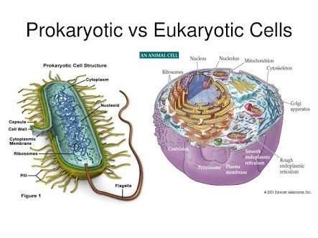
Prokaryotic: DNA found in the cytoplasm, not in a nucleus.

Safety Precaution In The Lab:
- Always remember to wear your lab coat during your work in the laboratory. Once finished, laboratory coats should not be worn outside the laboratory.
- Never Smoking, eat or drink in the lab, nor store food in areas where microorganisms are stored. Never eat or drink in the laboratory while working with microorganisms. Keep your fingers out of your mouth, and wash your hands before and after the laboratory activity. Cover any cuts on your hands with a bandage. Gloves may be worn as extra protection.
- Always wash your hands, keep hands and other objects away from your face, nose, eyes, ears, and mouth. The application of cosmetics in the laboratory is prohibited in the laboratory.
- Label everything clearly. All cultures, chemicals, disinfectant, and media should be clearly and securely labeled with their names and dates. If they are hazardous, label them with proper warning and hazardous information.
- Sterilize equipment and materials. All materials, media, tubes, plates, loops, needles, pipettes, and other items used for culturing microorganisms should be sterilized by autoclaving. Otherwise, use commercially sterilized products. Understand the operation and safe use of all equipment and materials needed for the laboratory.
- Treat all microorganisms as potential pathogens. While the majority of microorganisms are not pathogenic to humans and have never been shown to cause illness, under unusual circumstances a few microorganisms that are not normally pathogenic can act as pathogens. Treat all microorganisms—especially unknown cultures—as if they were pathogenic. A student who has a compromised immune system or has had a recent extended illness should talk with the instructor before working in the microbiology laboratory.
- Disinfect work areas before and after use. Use a disinfectant, such as a 10% bleach or 70% ethanol solution, to wipe down benches and work areas both before and after working with cultures. Also, be aware of the possible dangers of the disinfectant, as 70% ethanol can catch fire around open flame or high heat sources. Bleach, if spilled, can ruin your clothing. Either alcohol or bleach can be dangerous if splashed in the eyes. Students should know where the nearest eyewash station and sink are located.
- Autoclave or disinfect all waste material. All items to be discarded after a class, such as culture tubes, culture plates, swabs, toothpicks, wipes, disposable transfer needles, and gloves, should be placed in a biohazard autoclave bag and autoclaved 30 to 40 minutes at 121° C at 20 pounds of pressure. If no autoclave is available and you are not working with pathogens, the materials can be covered with a 10% bleach solution and allowed to soak for at least 1 to 2 hours.

- Sterilization Techniques.

Aim of the experiment: To study, the different method of sterilization and the purpose of sterilization.

Materials & Methods
Some chemicals are needed to show the students an example of the sterilizers and devices.

Identification: refers to the removal of all living microorganisms such as bacteria, fungi, algae, viruses and other microorganisms from an area.

Types of sterilization:
- Chemical sterilization.
- This method involves using chemicals to remove the microorganisms from the targeted surface, ex; alcohol swap, ethanol, dettol, Ozone, Glutaraldehyde and Formaldehyde, Phthalaldehyde, Hydrogen Peroxide,etc…
The concentration plays an important role in this method, for example; Alcohol to affect the concentration must be must be between 70% to 80%.

- Physical Sterilization.
This involves using physical factor such as radiation.
- Ultra Violet radiation (UV) is used to destroy all the microorganisms from the items, such as plastic and glass and other for 30- 45 minutes.
- Gamma radiation is also used sometimes.
- Filtration: by passing the solution through a filter with a pore diameter that is too small for microbes to pass through. This method is used more with sterilized liquid materials.

- Heat Sterilization.

- Dry heat
In the dry heat method we use the normal flame which generated by Bunsen burner.
Dry heat ensures that 15 ms around the flame is sterilized.
Oven can be used in some cases as as example of dry heat.
- Moist heat
In moist heat the most common device is the autoclave.
Autoclave uses both moist heat and pressure to sterilize the targeted item such as microbial media from the microbes. The conditional in the autoclave is 1-1.5 atmospheric pressure and 121 C for 15 minutes.

- Microbiology Culture Media: Types, Purpose, Examples.

Aim of the experiment: To study, types of the media and their used in the laboratory.

Material & Methods
Selective, General, Enriched and Differential media are required.

What is the culture medium?
Is a solid, liquid or semi-solid designed to support the growth of microorganisms. It contains the necessary elements for the growth of the microbes, source of C, N, minerals.

According to the status, culture media divided to:
- Liquid: no agar used in this kind of media (Broth).
- Semi-liquid: few amount of agar is used in this type approximately 0.5 or less.
- Solid: it contains agar between 1.5 to 2.0 %.

According to the purposes media are classified a following:
- General purpose media (Basic media).
This medium used for the growth of almost all kinds of microorganisms.
Examples; Nurtient Agar, Luria Broth, Potato Dextrose Agar, Plant Count Agar, etc…
Potato Dextrose Agar : common media used for cultivation of fungi.
Nutrient Agar: Most used media for growth of the bacteria.

- Selective Media.
Media used for the growth of selected microorganisms.
In this media a chemical ingredient used to prevent the growth of other microbes, such as antibiotic. Examples, Ampicillin media, Mannitol Salt gar,.

- Enriched media (Enrichment media).
Contain the nutrients required to support the growth of a wide variety of organisms, including some fastidious ones.
Some microorganisms require specific nutrient in order to grow.
Examples; Blood Agar and Chocolate Agar.

- Differential Media.
This kind of media contains chromogenic ingredient to give color with the growth of specific microorganisms.
Examples; Macconkeys Agar.

According to the origin of the media they are classified to:
- Natural media: media that are prepare using natural sourse.
- Synthetic media: natural media that are improved by chemicals.

- Isolation of Bacteria From Different Sourses (ex: skin , air, plants stem and leaf, tap water).

Aim of the experiment: To isolate microorganisms from different sources and show to prove to the student microbes are exist everywhere.

Materials & Methods
Media preparation:
- According to the plates required, weight the right amount of the powder media PDA and NG.
- Suspend the powder media in distilled water, shake gently to dissolve the powder.
- Sterilize the media in the autoclave under 1- 1.5 atmosphere pressure and 121 C for 15-20 minutes.
- Once the sterilization finished, carefully open the autoclave and wait until the temperature comes down.
- Prepare the petri dishes and sterilize the area where you will work, then pour the media to the dishes and wait for the solidification.
Growth condition for:
Bacteria: After inoculation the sample must be kept in the incubator for 24hours at 37 C.
Fungi: After inoculation the sample must be kept in the incubator for 4-5 days at 25 C.
Sample collection:
- Plant leaves and stems were collected from the college garden. While other samples were taken from the air and students fingerprint.

Tools:
- Microbial loops.
- Glass road.
- Tusbes to perform the dilutions.
- Plates to cultivate the microbes.
- Alcohol for the sterilization.

- Fungal growth hyphae (Fungal mycelium).
- Bacterial growth cells ( bacterial colonies).

- Serial Dilution Method: Identificaion, Purpose of Use + Isolation of Bacteria and Fungi From Soil.

Aim of the experiment: To isolate microorganisms from the soil using serial dilution method.
Materials & Methods
Media preparation:
- According to the plates required, weight the right amount of the powder media PDA and NG.
- Suspend the powder media in distilled water, shake gently to dissolve the powder.
- Sterilize the media in the autoclave under 1- 1.5 atmosphere pressure and 121 C for 15-20 minutes.
- Once the sterilization finished, carefully open the autoclave and wait until the temperature comes down.
- Prepare the petri dishes and sterilize the area where you will work, then pour the media to the dishes and wait for the solidification.

Tools:
- Microbial loops.
- Glass road.
- Tusbes to perform the dilutions.
- Plates to cultivate the microbes.
- Alcohol for the sterilization.
- Bunsen burner.

Growth condition for:
Bacteria: After inoculation the sample must be kept in the incubator for 24hours at 37 C.
Fungi: After inoculation the sample must be kept in the incubator for 4-5 days at 25 C.
Sample collection:
Soils were collected from the college garden mainly from the rhizosphere area around the roots.

Serial dilution method.
It is a method used to decrease the dilution of the substance. In microbiology, we used serial dilution to reduce the density of the living cell within our sample.

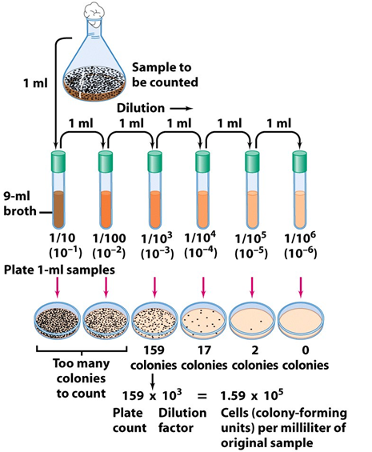

- As a result of the dilution we get a number of colonies which can be counted.
- The number of colonies then used to get the exact number of cells by demonstrating the above mentioned mathematical equation.
- The number of cells obtained from the equation then expressed as Colony forming units (CFU).
- Cultivation Techniques, Purification of Bacteria and Fungi.

Aim of the experiment: To purify both bacterial and fungal colonies to other plates, identify the difference in the bacterial and fungal colonies.
Materials & Methods
Media preparation:
- According to the plates required, weight the right amount of the powder media PDA and NG.
- Suspend the powder media in distilled water, shake gently to dissolve the powder.
- Sterilize the media in the autoclave under 1- 1.5 atmosphere pressure and 121 C for 15-20 minutes.
- Once the sterilization finished, carefully open the autoclave and wait until the temperature comes down.
- Prepare the petri dishes and sterilize the area where you will work, then pour the media to the dishes and wait for the solidification.

Growth condition for:
Bacteria: After inoculation the sample must be kept in the incubator for 24hours at 37 C.
Fungi: After inoculation the sample must be kept in the incubator for 4-5 days at 25 C.

Samples Collections:
Bacterial and fungal colonies isolated from the soils used in the experiment.
Tools:
- Microbial loops.
- Glass road.
- Tusbes to perform the dilutions.
- Plates to cultivate the microbes.
- Alcohol for the sterilization.
- Cork borer.
- Fungal needle.
- Bunsen burner.

Types of streaking:
For bacterial streaking
  - Simple zigzag streaking.
  - Triple streaking.
For fungal
- Disk inoculation.

- Staining Techniques: Bacteria, Concepts, How to perform?.

Aim of the experiment: To learn students staining techniques of microorganisms and the main concept behind the staining?

Materials & Methods
Gram- Staining kits in order to prepare the necessary amount for the experiments.

Tools:
- Bacterial Culture.
- Microbial loops.
- Glass roads.
- Tusbes to perform the dilutions.
- Plates to cultivate the microbes.
- Alcohol for the sterilization.
- Glass slides.
- Microscope and cedar oil.

Introduction to the light microscope:
The microscope is a device that enables us to study the tiny organisms that can not be seen by our naked eyes.
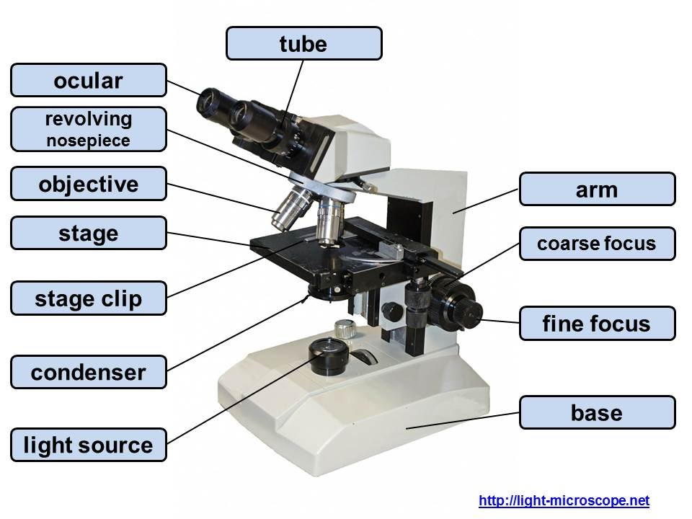

Why should we stain microorganisms?
Some microorganisms are colorless and can not be seen under the light microscope. Therefore, Staining gives a unique color to the microorganisms, so enable us to stand the morphology of the organisms and some colonial characters.
Stains are divided to:
Simple staining: in this type only one stain is used to stain the microorganisms.
One of the main disadvantage here is that all the microbes are stained with the same color of the stain.
Examples: DNA stain, capsule stains and Spores stain.

Differential staining: in this type more than one stain is used to give color to the microbes. In other wards, microbes pass through a series of stains.
Examples: Acid fast stain and Gram Stains

Before we start the staining the bacteria must be heat-fixed smear in a glass slide.

Grams Staining Procedure:
- Primary stain (crystal violet), For 1 minute.
- Wash
- The Mordant stain iodide, For 1 minute. Which binds to crystal violet and traps it in the cell.
- Wash.
- Decolorization with ethanol or acetone, For 30 seconds.
- Wash
- Counterstaining with safranin, For 1 minute.
- Wash and dry, then examine under the microscope with 100X.

After the staining according to the cell wall characteristics the microbes ill be divided to:
Gram positive bacteria (blue to purple in color).
Gram negative bacteria (red to pink in color).

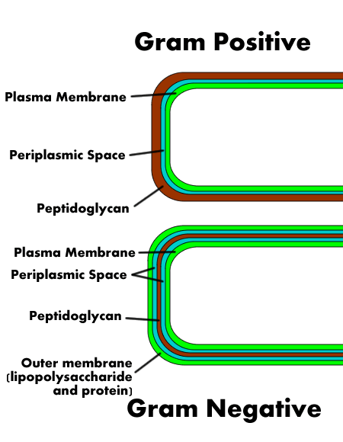

Bacterial Morphology under Microscope:
Bacilli or rod shape: Diolo, Strpto.
Cocci or sphere: Mono, Diolp, Strepto, Stapyllo.
Spirilla.
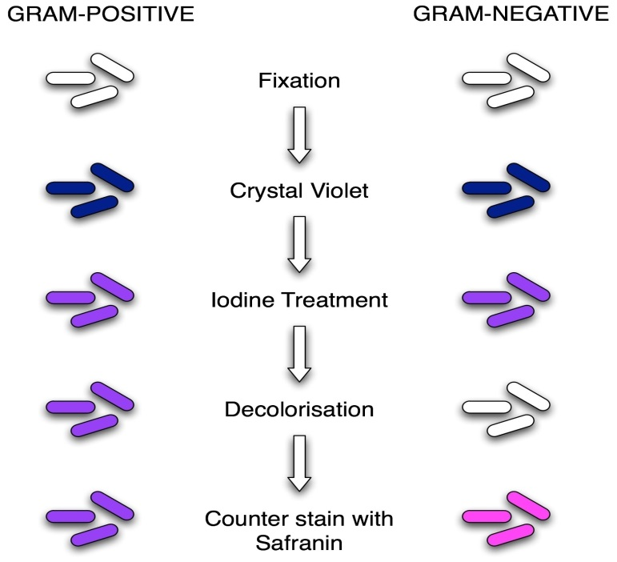

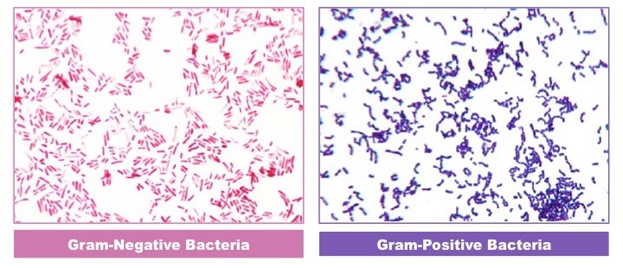

- Staining Techniques; Fungi, Concepts, How to perform?

Aim of the experiment: To learn the basic staining techniques of fungi.
Materials & Methods:
Lactophenol-cotton-blue kits in order to prepare the necessary amount for the experiments.

Tools:
- Fungal Culture.
- Fungal needle.
- Microbial loops.
- Alcohol for the sterilization.
- Glass slides.
- Cover slip.
- Microscope and cedar oil.
- Bunsen burner.
- Lacto-phenol-cotton-blue.

Lacto-phenol-cotton-blue is a complex stain that consists of:
- Lactic acid: to save the structure of the organism.
- Phenol: to kill the organism.
- Cotton blue: to give the unique color of the stain.

Procedures:
- In a glass slide place a drop of the Lactophenol-cotton-blue.
- Using fungal needle take a tiny piece of the mycelium.
- Put the tiny cut of mycelium in the drop of stain.
- Using cover slip, carefully cover the slide to avoid any air bubbles.
- Press the cover slip gently of the sample and examine it under the microscope in 4X, 10X and 40X.

- Mid-Semester Examination
Choose the Correct Answer: (Half Mark For Each Question )
(5 Marks)

- Cell wall of gram positive bacteria contains thick layer of:
A) Lipopolysaccharides. B) Cell membrane. C)Peptidoglycan. D) Protein.
Answer:
- Fungi are:
A) Prokaryotes. B) Ciliates. C)Eukaryotes. D) All of them.
Answer:
- Microorganisms are removed from the liquid by a process called:
A) Filtration. B) Plate count. C)Hydration. D) None of them.
Answer:
- Which of the following used as solidifying agent for the media:
A) Nutrient Agar. B) Selective media. C) Peptone. D) Non of them.
Answer:
- Which of the following is a complex media used for fungal growth:
A) NA. B) PDA. C) MEA. D) Luria Broth.
Answer:
- Grams Staining is an example of:
A) Simple Stain. B) Fast Stain. C) Protein Stain. D) Differential Stain.
Answer:
- Which of the following is the correct order for Gram- Staining:
- Crystal Violet – Alcohol - Iodine – Safranin.
- Safranin - Crystal Violet – Alcohol - Iodine.
- Crystal Violet - Iodine – Alcohol - Safranin.
- Iodine - Crystal Violet – Alcohol – Safranin.
Answer:
- In order to stain fungi we use:
A) Simple Stain. B) Fast Stain. C) Gram stain. D) lacto phenol Cotton blue.
Answer:
- In Gram- Staining, Iodine is used as:

- Secondary Stain. B) Primary Stain. C) Mordant Stain. D) Decolorization agent.
Answer:
- Which Bacteria appears violet- Purple in color after Gram-Staining:

- Gram Positive Bacteria. B) Gram Equal Bacteria. C) Gram Negative Bacteria. D) Fungi.
Answer:

(1 Marks)
Mention the types of media and give an example for each medium ?

- Introduction To Phycology & Virology and Their Importantance.

Aim of the experiment: To give students a clear idea about the structure and kinds of algae and viruses.
Materials & Methods
Theoretical concepts of algae and viruses.
What is algae?
Algae is a divers group of micro and macro organisms that inhibit the aquatic environments and have the ability to conduct photosynthesis.
Which means algae is Autotrophs.
Algae contains both eukaryotic and prokaryotic members.
A common media used for the growth of algae
- BG11 medium.
- Chu10 medium.
Growth condition for Algae:
- After inoculation the sample must be kept in the incubator for 7days at 25 C and a suitable light.
What is a Virus?
- The virus is non-living organism. It is an obligate intracellular parasite, which means they cannot live without a host cell.
- Every virus has a specific target cell, which means a pulmonary virus such as influenza virus cannot infect other organ fro example liver.
- Bacteriophage is a virus that infect bacteria.

Bacteriophage plaque assay is the most common used experiment to ensure that bacteriophage existence.

- Isolation of Anaerobic Microorganisms, Types, Catalase Test.

Aim of the experiment: To study the effect of oxygen on microorganisms, the mechanism behind the catalase test.
Materials & Methods
Hydrogen peroxide to perform catalase test.
Tools:
- Anaerobic media.
- Microbial loops.
- Alcohol for the sterilization.
- Glass slides.
- Cover slip.
- Bunsen burner.
- Hydrogen peroxide
- Anaerobic Jar.
According to the requirements of oxygen microbes are classified to:
- Aerobic microorganisms.
Oxygen is necessary for the growth of this group.
- Anaerobic microorganisms.
Ogygen is toxic for this group ex, Clostridium.
- Facultative microorganisms.
Live under oxygen condition, can grow when oxygen is absent.
- Microaerophils microorganisms.
Required a very little amount of oxygen.

Media for anaerobic microorganisms.
- Thioglycollate Agar.
- Robertsons cooked meat medium.

Catalse test
H2O2 H2O + O2.

Procedures:
- From microbial culture take a small portion of the colony.
- Put a drop of hydrogen peroxide on a glass slide.
- Mix the portion of the colony with the drop of the hydrogen peroxide.
- In case the microbe has the ability to eliminate oxygen by-product, ail bubbles can appear on the surface on the slide.

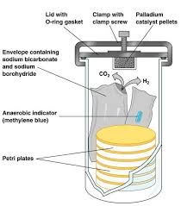
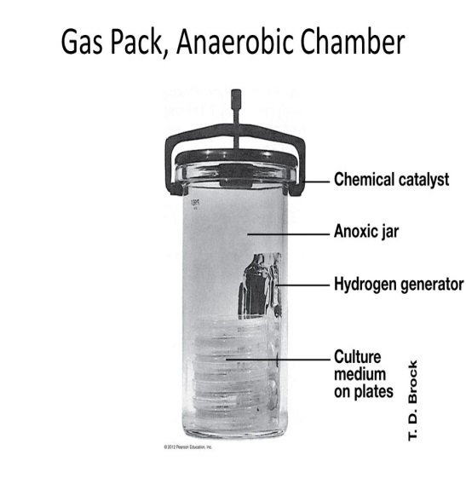

- Food Microbiology, Isolation of Microbrganisms From Food Sourse (Milk).

Aim of the experiment: To isolate microorganisms from food sources.

Materials & Methods

Media preparation:
- According to the plates required, weight the right amount of the powder media PDA and NG.
- Suspend the powder media in distilled water, shake gently to dissolve the powder.
- Sterilize the media in the autoclave under 1- 1.5 atmosphere pressure and 121 C for 15-20 minutes.
- Once the sterilization finished, carefully open the autoclave and wait until the temperature comes down.
- Prepare the petri dishes and sterilize the area where you will work, then pour the media to the dishes and wait for the solidification.

Mike is used as a source of food microorganisms.
Tools:
- Expired Milk.
- Microbial loops.
- Alcohol for the sterilization.
- Bunsen burner.
- Tests tubes for serial dilution.
- Culture media.
Milk composition:
- Proteins : Whey protein , Casein protein.
- Carbohydrates: such as Lactose.
- Vitamins & minerals such as A,B6,B12,C,D,K,E,…
- Enzymes.

Milk Bacteria converts lactose in the milk to lactic acid.
Lactose Lactic Acid.
The most known milk bacteria is Lactobacillus Acidophilus.

- Sensitivity Test.

Aim of the experiment: To understand the effect of antibiotics on the growth of microorganisms.

Materials & Methods
Procedures:
- The grown bacteria are known as a culture and bacteria in the culture will grow and multiply. The bacteria will form colonies, or large groups of bacteria, that will each be exposed to different antibiotics.
- Based on the availability of the material you do the test by either disk or well method .

Media preparation:
- According to the plates required, weight the right amount of the powder media PDA and NG.
- Suspend the powder media in distilled water, shake gently to dissolve the powder.
- Sterilize the media in the autoclave under 1- 1.5 atmosphere pressure and 121 C for 15-20 minutes.
- Once the sterilization finished, carefully open the autoclave and wait until the temperature comes down.
- Prepare the petri dishes and sterilize the area where you will work, then pour the media to the dishes and wait for the solidification.

Tools:
- Microbial loops.
- Baerial culture.
- Fungal culture.
- Plates to cultivate the microbes.
- Alcohol for the sterilization.
- Cork borer.
- Fungal needle.
- Bunsen burner.

Why is the Sensitivity test? Or Susceptibility test?
- Is a test used to study the effect of a compound or any antibiotic on the growth of bacteria and fungi and form clean zones in the media.
- Sensitivity analysis is a useful tool to help quickly determine if bacteria are resistant to certain drugs.
Sensitivity test can be performed in two different ways:
- Well method:
In this method we make a wells or holes on the surface of the media to pour our liquid compound or antibiotic.
- Filter paper disk method:
In this method small desk from filter paper are prepared and the required concentration of the antibiotic inoculated with it.
In some cases the disk brought already prepared by a company.

As a result of the sensitivity test bacterial can be divided into three types:
- Resistant: where the antibiotics have no effect on them. No clean zones.
- Moderately resistant: there is a small, clean zone around the colony. Small clean zones.
- Affected: the antibiotics completely prevent the growth of the bacteria. large clean zones.
Minimum inhibitory concentration (MIC):
Is the lowest concentration of a chemical, usually a drug, which prevents visible growth of bacteria.

- Revision

- Final Exam

