King Saud University
Information Systems Department

Project Management (IS-351)

Home Work # 2

Student Name:-___________________________ | Section No.: _________
SID No.: ________________________________ | Student Class No.: ________
Total Marks:- 10 | Marks Awarded:__________
=====================================================================

Question 1: Match column (A) with column (B) (3.5 points)

Number index | COLUMN (A) | Alphabet Index | COLUMN (B)
[1] | WBS is an acronym for | [P] | A document that formally recognizes the existence of a project and provides direction on the project’s objectives and management
[2] | A scope statement is | [Q] | Critical Path Method
[3] | A project charter is | [R] | The series of activities that determine the earliest time by which the project can be completed.
[4] | CPM is an acronym for | [S] | A resource works on more than one task at a time
[5] | A critical path for a project is | [T] | a document used to develop and confirm a common understanding of the project scope
[6] | Multitasking occurs when | [U] | Work breakdown structure
[7] | Program Evaluation and Review Technique (PERT) | [V] | Uses probabilistic time estimates –duration estimates based on using optimistic, most likely, and pessimistic estimates of activity durations-instead of one specific or discrete estimate.

ANSWER:
Number Index in Column A | [1] | [2] | [3] | [4] | [5] | [6] | [7]
Matching alphabet Index in Column B | [ ] | [ ] | [ ] | [ ] | [ ] | [ ] | [ ]

Question 2: (2 points)

- Carefully read the three following statements labelled A, B, C and D based on the diagram shown below in figure 5-2:

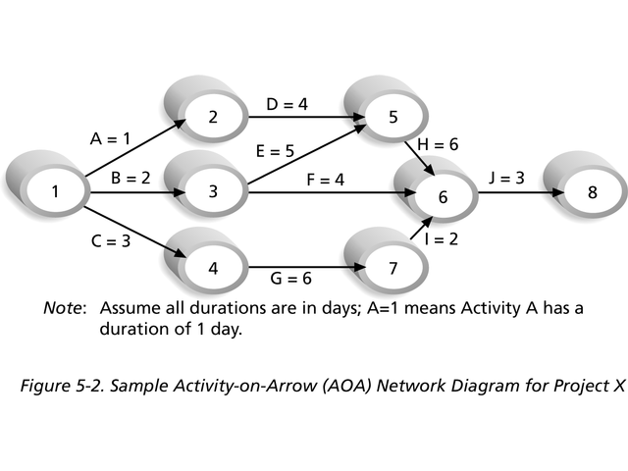
- In the Activity-on-Arrow diagram, shown in the above figure, the number 8 represents
a node.
B) In the Activity-on-Arrow diagram, shown in the above figure, the two nodes labelled 3 and 6 respectively, represent the starting and ending point of activity F.
C) In the Activity-on-Arrow diagram, shown in the above figure, the first node labelled 1 signifies the start of the project.
D) In the Activity-on-Arrow diagram, shown in the above figure, the node labelled 6 signifies the end of the project, because many arrows are meeting at this node.

- Answer by putting an (*) in the vacant cells of the table provided, indicating your judgement as (T) or (F) or (I don’t know) to the indexed statements of the table labelled as 1, 2, 3 and 4 respectively. Only one choice is correct. In case of more than one choice, the answer is null.

ANSWER:
Index | Statement to be judged as (T) , (F) or (I don’t know) | T | F | I don’t know
1 | The information provided in Statement (A) is not correct
2 | The information provided in Statement (B) is not correct
3 | The information provided in Statement (C) is correct
4 | The information provided in Statement (D) is correct

Question 3: (4.5 points)
Inspect the diagram shown below then answer the questions related to it.

Q 3.a How many path(s) are in this diagram starting from node 1 to node 8? (0.5 point)

ANSWER: ___________________________________________________________________

Q 3.b Name the path(s) that are in this diagram starting from node 1 to node 8? (0.5 point)

ANSWER: ___________________________________________________________________

Q 3.c How many critical path(s) are in this diagram starting from node 1 to node 8? (0.5 point)

ANSWER: ___________________________________________________________________

Q 3.d Name the critical path(s) that are in this diagram starting from node 1 to node 8?
(0.5 point)

ANSWER: ___________________________________________________________________

Q 3.e What is the shortest time to complete the project whose activities are shown in the figure? (0.5 point)

ANSWER: ___________________________________________________________________

Q 3.f Based on the same diagram, name the activity that must be done before activity D? (0.5 point)

ANSWER: ___________________________________________________________________

Q 3.g Based on the same diagram, name the activity that must be done before activity G? (0.5 point)

ANSWER: ___________________________________________________________________

Q 3.h Based on the same diagram, name the two nodes that represent the final activity of this project? (0.5 point)

ANSWER: ___________________________________________________________________

Q 3.h Based on the same diagram, name the two nodes that represent activity G of this project? (0.5 point)

ANSWER: ___________________________________________________________________

Question 4: Bonus question (1 point)
Define the following term: Critical Chain Scheduling.
ANSWER: ___________________________________________________________________

______________________________________________________________________________________________________________________________________________________________________________________________________________________________________________________________________________________________________________________________________________________________________________________________________

Q1 /3.5 pts | Q2 /2pts | Q3 /4.5pts | Q4 /1pt  (BONUS)
[ / 3.5 ] | [ / 2 ] | [ / 4.5 ] | [ / 1 ]

Mark out of [10] | Mark out of [1.25]

