King Saud University
Information Systems Department

Project Management (IS-351)

Home Work # 2 (ANSWERS)

Student Name:-___________________________ | Section No.: _________
SID No.: ________________________________ | Student Class No.: ________
Total Marks:- 10 | Marks Awarded:__________
=====================================================================

Question 1: Match column (A) with column (B) (3.5 points)

Number index | COLUMN (A) | Alphabet Index | COLUMN (B)
[1] | WBS is an acronym for | [P] | A document that formally recognizes the existence of a project and provides direction on the project’s objectives and management
[2] | A scope statement is | [Q] | Critical Path Method
[3] | A project charter is | [R] | The series of activities that determine the earliest time by which the project can be completed.
[4] | CPM is an acronym for | [S] | A resource works on more than one task at a time
[5] | A critical path for a project is | [T] | A document used to develop and confirm a common understanding of the project scope
[6] | Multitasking occurs when | [U] | Work breakdown structure
[7] | Program Evaluation and Review Technique (PERT) | [V] | Uses probabilistic time estimates –duration estimates based on using optimistic, most likely, and pessimistic estimates of activity durations-instead of one specific or discrete estimate.

ANSWER:
Number Index in Column A | [1] | [2] | [3] | [4] | [5] | [6] | [7]
Matching alphabet Index in Column B | [ U ] | [ T ] | [ P ] | [ Q ] | [ R ] | [ S ] | [ V ]

Question 2: (2 points)

- Carefully read the three following statements labelled A, B, C and D based on the diagram shown below in figure 5-2:

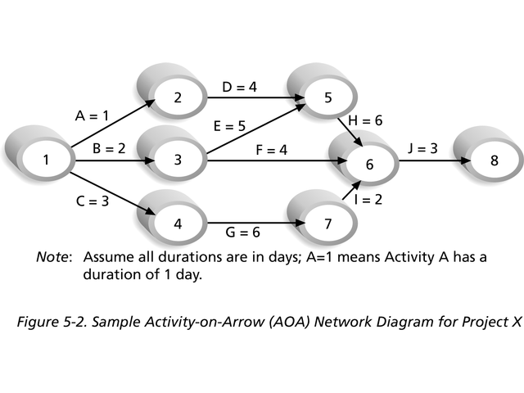
- In the Activity-on-Arrow diagram, shown in the above figure, the number 8 represents
a node.
B) In the Activity-on-Arrow diagram, shown in the above figure, the two nodes labelled 3 and 6 respectively, represent the starting and ending point of activity F.
C) In the Activity-on-Arrow diagram, shown in the above figure, the first node labelled 1 signifies the start of the project.
D) In the Activity-on-Arrow diagram, shown in the above figure, the node labelled 6 signifies the end of the project, because many arrows are meeting at this node.

- Answer by putting an (*) in the vacant cells of the table provided, indicating your judgement as (T) or (F) or (I don’t know) to the indexed statements of the table labelled as 1, 2, 3 and 4 respectively. Only one choice is correct. In case of more than one choice, the answer is null.

ANSWER:
Index | Statement to be judged as (T) , (F) or (I don’t know) | T | F | I don’t know
1 | The information provided in Statement (A) is not correct |  | *
2 | The information provided in Statement (B) is not correct |  | *
3 | The information provided in Statement (C) is correct | *
4 | The information provided in Statement (D) is correct |  | *

Question 3: (4.5 points)
Inspect the diagram shown below then answer the questions related to it.

Q 3.a How many path(s) are in this diagram starting from node 1 to node 8? (0.5 point)

ANSWER:_______FOUR (4)________________________________________

Q 3.b Name the path(s) that are in this diagram starting from node 1 to node 8? (0.5 point)

ANSWER: _[ A D H J ] , [B E H J ] , [ B F J ] , [C G I J ]

Q 3.c How many critical path(s) are in this diagram starting from node 1 to node 8? (0.5 point)

ANSWER: _ ONE (1)

Q 3.d Name the critical path(s) that are in this diagram starting from node 1 to node 8?
(0.5 point)

ANSWER: ________[B E H J ] __________________________________________

Q 3.e What is the shortest time to complete the project whose activities are shown in the figure? (0.5 point)

ANSWER: _______Sixteen Days (16)_____________________________________

Q 3.f Based on the same diagram, name the activity that must be done before activity D? (0.5 point)

ANSWER: ___________[ A ]_____________________________________________________

Q 3.g Based on the same diagram, name the activity that must be done before activity G? (0.5 point)

ANSWER: _____________________[ C ]

Q 3.h Based on the same diagram, name the two nodes that represent the final activity of this project? (0.5 point)

ANSWER: ______________Nodes 6 and 8.______________________________________

Q 3.h Based on the same diagram, name the two nodes that represent activity G of this project? (0.5 point)

ANSWER: Nodes 4 and 7.______________________________________

Question 4: Bonus question (1 point)

Define the following term: Critical Chain Scheduling.
ANSWER: Critical chain Scheduling is a method of scheduling that takes limited resources into account when creating a project schedule and includes buffers to protect the project completion date. Critical Chain Scheduling assumes that resources do not multitask. Someone cannot be assigned to two tasks simultaneously on the same project, when critical chain scheduling is in effect. Feeding buffers are added to protect tasks from being delayed.___________________________________________________________________

Q1 /3.5 pts | Q2 /2pts | Q3 /4.5pts | Q4 /1pt  (BONUS)
[ / 3.5 ] | [ / 2 ] | [ / 4.5 ] | [ / 1 ]

Mark out of [10] | Mark out of [1.25]

