King Saud University
Information Systems Department

Project Management (IS-351)

Home Work # 1

Student Name:-___________________________ | Section No.: _________
SID No.: ________________________________ | Student Class No.: ________
Total Marks:- 10 | Marks Awarded:__________
=====================================================================

Question 1: How is project management different from general management? (1 point)

ANSWER: Project management overlaps with general management. Project managers, use unique project management skills to focus on integrating all of the knowledge areas required to successfully complete a project. General Managers perform routine day to day tasks. General management establishes all the operational needs of running a business.

Question 2: Name two deliverables for the Implementation phase of the project. (2 points)

ANSWER: Definitive Cost Estimates. Performance Reports.

Question 3: (3 points)
- First, inspect the different organizational structures in the figure below.

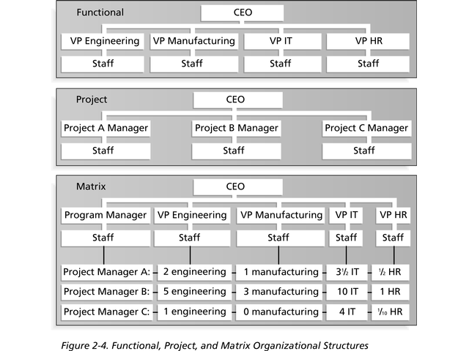(II) Carefully read the three following statements labelled A, B and C:
A) In a project organizational structure, vice presidents report to the CEO
B) Project managers in a matrix organization, have staff from various functional
areas working on their projects.
C) CEO is an acronym for Current Executive Officer

(III) Answer by putting an (*) in the vacant cells of the table provided, indicating your judgement as (T) or (F) or (I don’t know) to the indexed statements of the table labelled as 1, 2 and 3 respectively. Only one choice is correct. In case of more than one choice, the answer is null.
ANSWER:
Index | Statement to be judged as (T) , (F) or (I don’t know) | T | F | I don’t know
1 | The information provided in Statement (A) is not correct | *
2 | The information provided in Statement (B) is not correct |  | *
3 | The information provided in Statement (C) is correct |  | *

Question 4: What does project integration management mean? (1 point)

ANSWER: Project Integration Management involves coordinating all of the other project management knowledge areas throughout a project’s life cycle. It ensures that all of the elements of a project come together at the right times to complete a project successfully.

Question 5: What are the three main processes involved in project integration management? Give a brief explanation for each one. (3points)

ANSWER: The main processes involved in project integration management include:

- Project Plan Development, which involves putting the results of other planning processes into a consistent, coherent document- the project plan.

- Project Plan Execution, which involves carrying out the project plan by performing the activities included in it.

- Integrated Change Control, which involves coordinating change across the entire project.

Q1/1pt | Q2/2pts | Q3/3pt | Q4/1pt | Q5/3pts
[ / 1 ] | [ / 2 ] | [ / 3 ] | [ / 1 ] | [ / 3 ]

Mark out of [10] | Mark out of [1.25]

