Question 1:
Based on LDH electrophoretic patterns, what is each patient likely diagnosis.

Patient 4
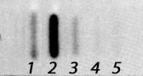

Diagnosis:---------------------------------------------------------------------------------------------------------------------------------------------------------------------------------------------------------------------------------------------

Patient 3
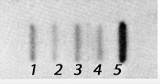

Diagnosis:---------------------------------------------------------------------------------------------------------------------------------------------------------------------------------------------------------------------------------------------

Patient 2
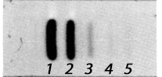

Diagnosis:---------------------------------------------------------------------------------------------------------------------------------------------------------------------------------------------------------------------------------------------

Patient 1
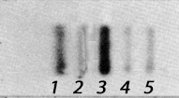

Diagnosis:---------------------------------------------------------------------------------------------------------------------------------------------------------------------------------------------------------------------------------------------

