CEN455: Introduction Digital Control
Home-Work 1: 1st Semester 1439-1440
ID: | Name:

Problem1:

Given the electric network shown in Figure:
1. Write the differential equation for control solutions the network if v(t) = u(t), a unit step.
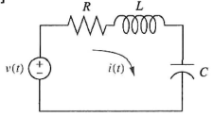

2. Solve the differential equation for the current, i(t), if there is no initial energy in the network.

3. Make a plot of your solution if$\frac{R}{L}=1$
Problem2:
Find the transfer function, G(s) for system shown in Figures.
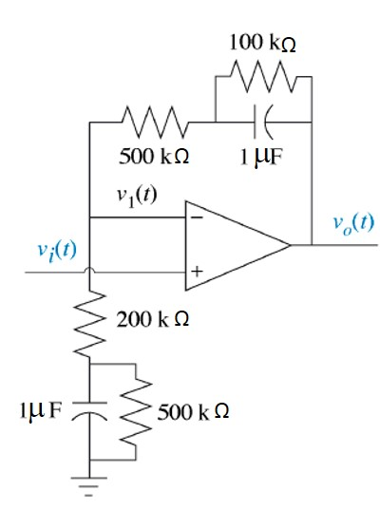

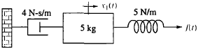

$G\left(s\right)=\frac{V_{0}(s)}{V_{i}(s)}$ $G\left(s\right)=\frac{X_{1}(s)}{F(s)}$

Problem3:
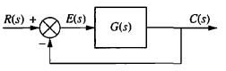
For the unity feedback system,

1. Find the steady-state error for inputs of $30 u\left(t\right), 70 t u\left(t\right), and 81 t^{2}u\left(t\right) if$
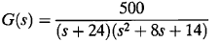

2. Find the range of K for closed-loop stability if:
